**Notices:** Today it is Trinity Sunday – a special day of celebrating the Father, Son and Holy Spirit, hence the colours are white and gold. We’ve changed back to our liturgy for Ordinary Time and the colours will be green again from next Sunday. The readings today may sound familiar – spot the words of ‘The Grace’, a prayer that we still use today, every week at our Wednesday reflection group. The Gospel reading is known as ‘The Great Commission’. The last 2 verses, right at the end of Matthew’s Gospel, are a succinct summary of what it means to be a Christian. How do we reflect that as Christians in 2023?

**Every Sunday 11am:** Communion service with coffee afterwards

**Gospel Reflections on Wednesdays at 10.30am** in the Sitting Room, followed by coffee at 11.15. Enter down the north (Ferry Road) side of the church through the porch at the end of the passage. The Reflection Group will be taking a holiday in July and August, back on Wednesday 6th September.

Please pray for the **Vestry meeting this week**, Tuesday 6th June at Jane’s house – 7pm drinks for 7.30pm meeting.

**Mission Action Plan:** Thanks to everyone who took part in the Mission Action Planning workshop. As a Vestry, we’re currently collating all the information and will be sending it to everyone soon.

**If you are emailing the office, please use our new address:** [stjamesgoldenacre@gmail.com](mailto:stjamesgoldenacre@gmail.com). Don’t forget to add it to your email address book so our emails to you don’t get junked!

**Contact Details**: Revd Jane Maclaren [rector@stpj.org.uk](mailto:rector@stpj.org.uk) 07709905528. Jane works Saturday to Wednesday and takes a ‘weekend’ on Thursday-Friday.

Church Administrator Wendy Lap [stjamesgoldenacre@gmail.com](mailto:stjamesgoldenacre@gmail.com) Wendy works 10:00 - 14:00 Monday, Wednesday, Friday and is on leave 8-14th June

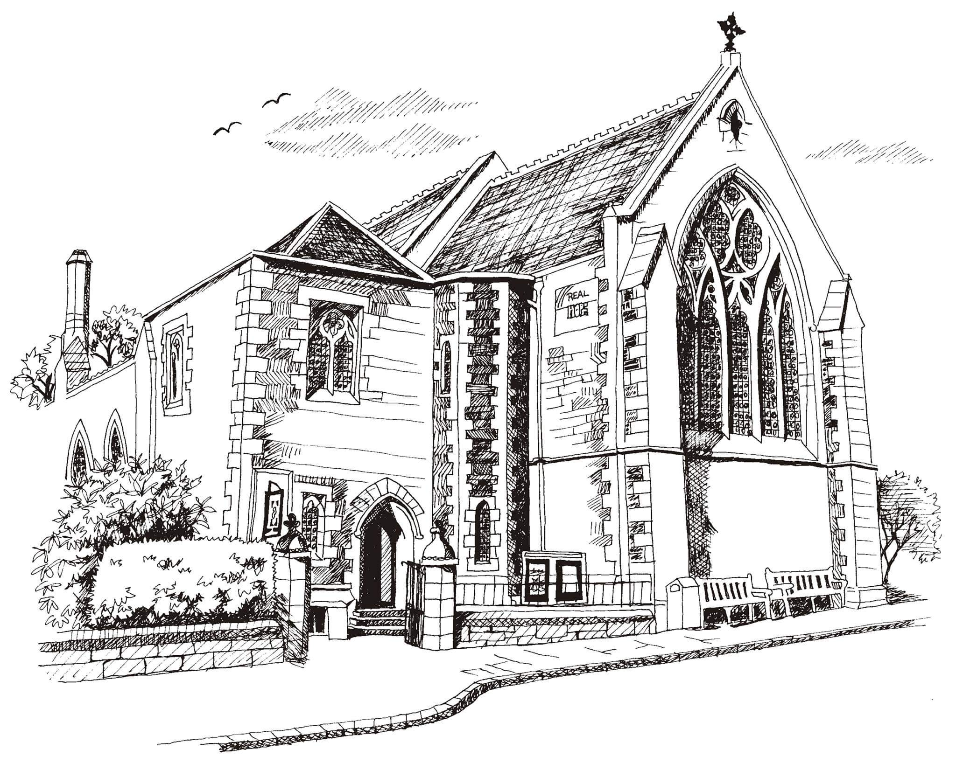**St Philip’s and St James’**

**Church Goldenacre**

**Holy Communion**

**4th June 2023**

**Trinity Sunday**

|  |  |
| --- | --- |
| Hymn 286 | Holy, Holy, Holy |
| Liturgy of the Word | Rachel |
| Collect for Trinity Sunday  Almighty and Everlasting God, you have given us grace in the profession of true faith to recognise the glory of the eternal Trinity: keep us steadfast in this faith and bring us to see you in your perfect and eternal unity; through Jesus Christ our Lord, who lives and reigns with you, in the unity of the Holy Spirit, one God, world without end. | |
| Readings – Norman | Isaiah 40:12-17, 27-31  2 Corinthians 13.11-13 |
| Gospel – Jane | Matthew 28.16-20 |
| Reflection | Rev Jane MacLaren |
| Intercessions | Peter |
| Hymn 195 | The Servant King |
| Communion | Rev Jane MacLaren |
| Hymn 314 | Immortal Invisible |

Scottish Liturgy 1982 – Epiphany St James Goldenacre Reg Charity SC000910

See the website for news and information: [www.stpj.org.uk](http://www.stpj.org.uk). If you miss a week, you can get the notice sheet under ‘latest’.