**Notices:** This week we celebrate the coming of the Holy Spirit at Pentecost. What does it mean to be ‘filled with the Holy Spirit’ and what do we make of the amazing story with all those different languages and everyone able to understand because they were hearing the good news in their own mother tongue! We welcome David Bunyan, celebrating Communion and preaching for us today.

**If you are emailing the office, please use our new address:** [stjamesgoldenacre@gmail.com](mailto:stjamesgoldenacre@gmail.com). Don’t forget to add it to your email address book so our emails to you don’t get junked!

**Every Sunday 11am:** Communion service with coffee afterwards

Next week is Trinity Sunday.

**Gospel Reflections on Wednesdays at 10.30am** in the Sitting Room, followed by coffee at 11.15. Enter down the north (Ferry Road) side of the church through the porch at the end of the passage.

**Saturday 3rd June 10.30-3.30pm** – **The Big Story at the Cathedral.** Come and join in with workshops, lunch and worship. All our churches in Edinburgh Diocese are getting together for workshops, worship and sharing our stories. Come with Jane and represent St James! For more information and to sign up for lunch go to [edinburgh.anglican.org/event/the-big-story](https://edinburgh.anglican.org/event/the-big-story)

**Mission Action Plan:** Thanks to everyone who took part in the Mission Action Planning workshop. As a Vestry, we’re currently collating all the information and will be sending it to everyone soon.

**Contact Details**: Revd Jane Maclaren [rector@stpj.org.uk](mailto:rector@stpj.org.uk) 07709905528. Jane is back on Tuesday this week and works Saturday to Wednesday.

Church Administrator Wendy Lap [stjamesgoldenacre@gmail.com](mailto:stjamesgoldenacre@gmail.com) Wendy works 10:00 - 14:00 Monday, Wednesday, Friday.

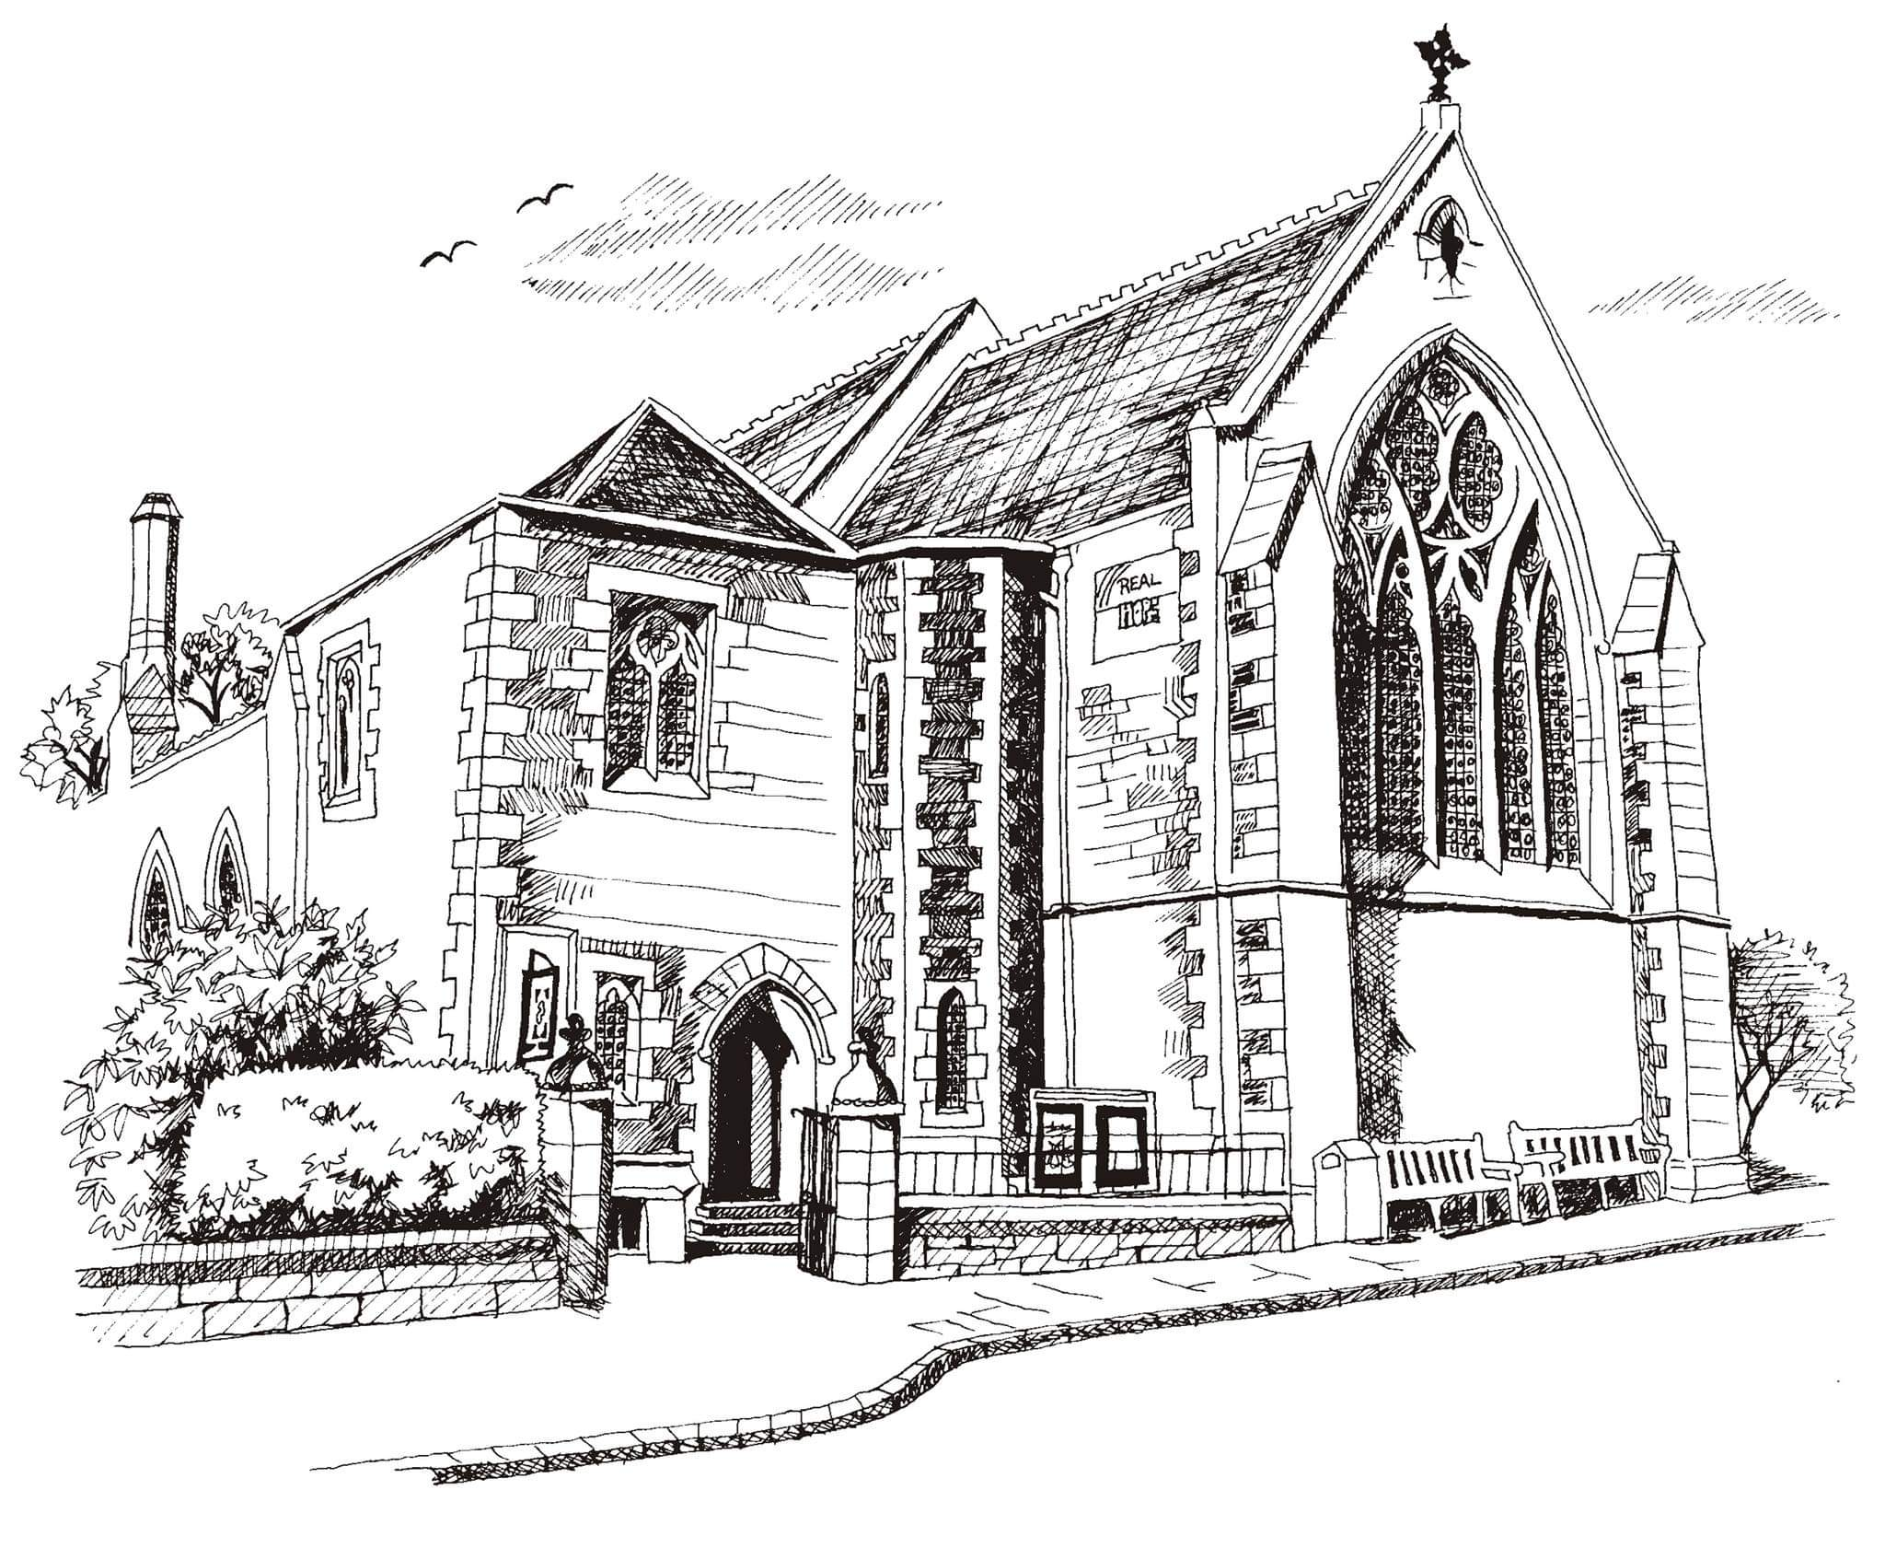**St Philip’s and St James’**

**Church Goldenacre**

**Holy Communion**

**28th May 2023**

**The Day of Pentecost**

|  |  |
| --- | --- |
| Hymn 114 | Come down, o love divine |
| Liturgy of the Word | Rachel |
| *Collect for The Day of Pentecost*  O God, who on the day of Pentecost enlightened the hearts of your people by the fire of the Holy Spirit: give us wisdom and understanding, and lead us into all truth, that your Church may be kept in the unity of the Spirit and the bond of peace; through Jesus Christ, our Lord, who live and reigns with you, in the unity of the same Spirit, one God, world without end. | |
| Readings – Robert | Acts 2.1-21; Corinthians 12.3b-13 |
| Gospel – David B | Matthew 28-16-20 |
| Reflection | David B |
| Intercessions | Anne |
| Hymn 118 | Come holy ghost, our souls inspire |
| Communion | David B |
| Hymn 716 | We have a gospel to proclaim |

Scottish Liturgy 1982 – Epiphany St James Goldenacre Reg Charity SC000910

See the website for news and information: [www.stpj.org.uk](http://www.stpj.org.uk). If you miss a week, you can get the notice sheet under ‘latest’.