**Notices:** This week we have been celebrating the Ascension of Jesus. It’s a very strange story from an earthly perspective. You can find it in Luke 24:44-53. It’s all about completion, vindication, and the glory of Christ. You can see the idea of it reflected in the triptych at our High altar. Today we are looking at John 17 where Jesus talks to the Father about leaving the earth and prays for his followers left behind. That includes us! How does Jesus’ prayer for us inform our priorities?

**We have a new church email address:** [stjamesgoldenacre@gmail.com](mailto:stjamesgoldenacre@gmail.com)

Please add it to your email address book so our emails to you don’t get junked!

**Every Sunday 11am:** Communion service with coffee afterwards

Next week David Bunyan will be with us to celebrate **Pentecost.**

**Gospel Reflections on Wednesdays at 10.30am** in the Sitting Room, followed by coffee at 11.15. Enter down the north (Ferry Road) side of the church through the porch at the end of the passage.

**Saturday 3rd June 10.30-3.30pm** – **The Big Story at the Cathedral.** All our churches in Edinburgh Diocese are getting together for workshops, worship and sharing our stories. Come with Jane and represent St James! Free lunch provided. **We need:** offers of home baking, someone to help set up for 10.30am and someone for the stall for a couple of hours. Please see Jane if you can offer anything. For more information and to sign up for lunch go to [edinburgh.anglican.org/event/the-big-story](https://edinburgh.anglican.org/event/the-big-story)

**Contact Details**:

Revd Jane Maclaren [rector@stpj.org.uk](mailto:rector@stpj.org.uk) 07709905528. Jane works Saturday to Wednesday and takes Thursday and Friday as a ‘weekend’.

Church Administrator Wendy Lap [stjamesgoldenacre@gmail.com](mailto:stjamesgoldenacre@gmail.com) Wendy works 10:00 - 14:00 Monday, Wednesday, Friday.

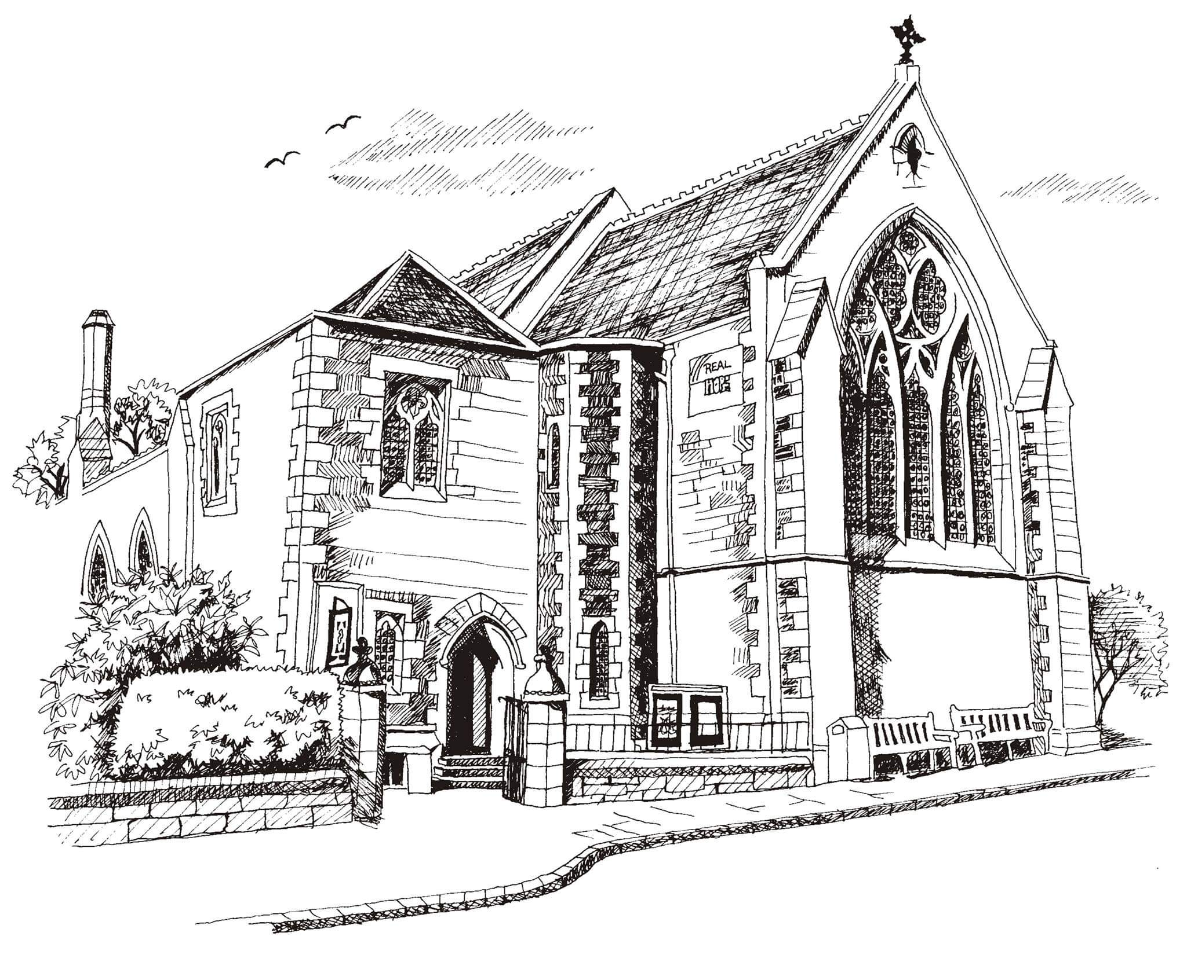**St Philip’s and St James’**

**Church Goldenacre**

**Holy Communion**

**21st May 2023**

**Easter 7**

|  |  |
| --- | --- |
| Hymn 54 | At the name of Jesus  (verses 1,2,5,6) |
| Liturgy of the Word | Una |
| *Collect for Easter 7*  O God, the King of Glory, hear our prayer: that as we believe your Son, Jesus Christ to be exalted with great triumph to your kingdom in heaven; so also, we may know his presence with us now, and to the end of time; who lives and reigns with you, in the unity of the Holy Spirit, one God, world without end. | |
| Readings – Margaret | Acts 1.6-14  1 Peter 4.12-14 / 5.6-11 |
| Gospel – Jane | John 17.1-11 |
| Reflection | Jane |
| Intercessions | Rosemary |
| Hymn 461 | My Jesus, my saviour |
| Communion | Rev Jane MacLaren |
| Hymn 448 | Meekness and majesty |

Scottish Liturgy 1982 – Epiphany St James Goldenacre Reg Charity SC000910

See the website for news and information: [www.stpj.org.uk](http://www.stpj.org.uk)