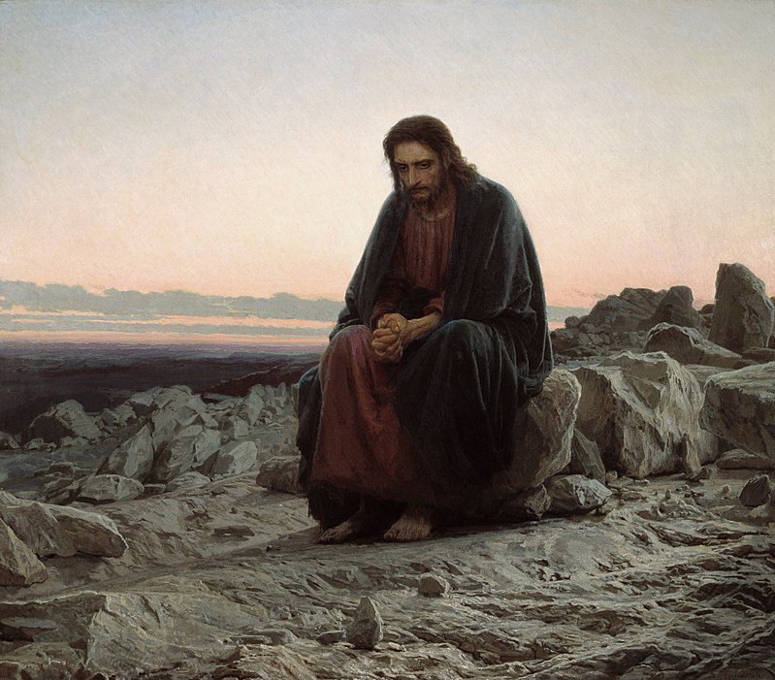
A voice from heaven said ‘this is my Son, the Beloved in whom I am well pleased. Then Jesus was led by the Spirit into the wilderness to be tempted by the devil.
Matthew tells us that Jesus sets off for the wilderness immediately after hearing that voice from heaven at his baptism. He’s going to spend time in prayer and fasting for as long as it takes.
40 days to delve deep inside himself, to keep his eyes fixed on God as he faces one temptation after another and learns more about who he really is – God’s Son, the beloved.
40 days to grow in self-awareness as he discovers what it might mean to be God’s Son as 30 years of preparation come to an end and his ministry begins.
Our own 40 days of Lent began on Wednesday when many of us received a cross marked in ash on our foreheads as we thought about our mortality, our temptations and how we so often fail to keep our eyes fixed on God.
Lent offers us the great gift of 40 days. – 40 days to step away from our busy lives and spend time in our own wilderness to help us deepen our understanding of what it really means to walk the way of Jesus, to learn more about ourselves as we face our own temptations and to hear that we too are God’s beloved children.
The image in your hands was painted 150 years ago by the Russian portrait painter Ivan Kramskoi. Kramskoi was a man of deep faith, a sensitive and compassionate artist who spent ten years reflecting on Christ’s time in the wilderness before he began this painting which took another five years to complete.
His aim was to share with the viewer – with you and me - his own spiritual and emotional journey over those 15 years.
He wrote this: “I want to place a mirror in front of people’s faces, by which their hearts would be awakened by the sound of an alarm.”
Kramskoi wanted to capture Jesus on canvas as a man who everyone could relate to – a Jesus who faced the same struggles and temptations as we do, a man who suffered pain and heartache. He wanted us to be able to relate our own human experience to his Jesus.
Jesus sits bent over with bowed head on a rock in the centre of an empty landscape. He is exhausted, hungry and alone. His face shows an expression of humility and acceptance. His feet are bloody from walking barefoot on rough rocks and we get a jolt when we realise how much Christ is hurting here, physically, emotionally, and mentally.
The landscape is empty apart from Christ in the centre. It shows two worlds, - a cold and lifeless desert beneath and a rising new dawn above, the glow of a new day - hope in a barren desert. Jesus’ hands are tightly clenched and placed by Kromskoi exactly where these two worlds meet – so we are reassured that with these hands new life will be created. His long sleepless night is almost at an end, and dawn is on the way.
Every day for 40 days, Jesus had to decide whether or not to stay faithful to the voice from heaven. And in his solitude, he had space to listen to God, to reflect and learn and grow into what it might really mean to be God’s son, the beloved.
To learn more about his identity and his ministry. Kromskoi wanted this image of Christ in the Wilderness to offer those same opportunities to us.
He wrote this: “I see clearly that there is one moment in the life of every person created in the image and likeness of God to some extent, when he thinks about whether to go to the right or to the left, whether to sell the Lord God for a rouble or not?”
These 40 days of Lent offer us an opportunity to take time away from the busy world, to learn more about ourselves and what it really means to be God’s beloved sons and daughters. Taking time to examine ourselves and grow in self-awareness can be an uncomfortable process as we begin to face the truths we often try to hide. But when we do discover our true identity and begin to live into our authentic selves, we will discover new life in Christ in a deep and profound way.
For many years, the emphasis in Lent has been placed on self-denial – on giving up the things we enjoy, but Kromskoi offers us instead a Jesus who encourages us to use these 40 days of Lent to relate our human experience to that of Christ so that we might grow in self-knowledge and into the fullness of the knowledge of God. Music
What can I learning about myself this Lent to help me to grow into my real self?
What do I need from God right now?

