**Notices:** The Old Testament reading for today is the story of Samuel anointing David as King – that’s Samuel who was the small boy in the Temple that God called through the dark, and David the youngest of the family with all those older brothers, who defeated the giant Goliath with one little stone. Clearly God works through all sorts of different people. What does it mean for God to call us?

**Wednesdays 10.30-11.30am – Lent Course and Coffee:** ‘Faith is a verb’. This week **Weds 15th March:** ‘Listening’. In the ‘Sitting Room’.

**Holy Week - Dates for your diary:**

**Palm Sunday 2nd April 11am –** Gather in the Sitting room for the procession through church to our last Sunday service in the hall

**Wednesday 5th April 10.30 am** – final Lent group: ‘Dying’

**Maundy Thursday 6th April** 7.30pm – Last Supper Service with Communion in the Hall

**Good Friday 7th April** 7pm – Ecumenical Tenebrae service at Inverleith St Serfs

**Holy Saturday 8th April 10am – 12.30** – prayers and church clean-up

**Easter Vigil 8-9pm** at St Ninians Comely Bank Road

**Easter Sunday** **9th April** - Back in church. Jane Green’s last day with us. Bring and share lunch; please stay and bring food! To contribute to Jane G’s leaving gift please give money to Jane Mac in an envelope marked ‘Jane’ or pay direct to the bank ref ‘Jane G’ (details below).

**Bishop’s Lent Appeal:** for a water filtration project at St Nicholas Theological seminary in our partner Diocese of Cape Coast, Ghana. More info here: [www.edinburgh.anglican.org/bishops-lent-appeal-2023/](http://www.edinburgh.anglican.org/bishops-lent-appeal-2023/) Please donate by cheque or bank transfer to St Philips and St James Church, marked ‘Lent Appeal’. Acc 00787069 Sort 80-02-33

**Contact Details**: Revd Jane Maclaren 07709905528 rector@stpj.org.uk

Revd Jane Green 07914856606 associate@stpj.org.uk

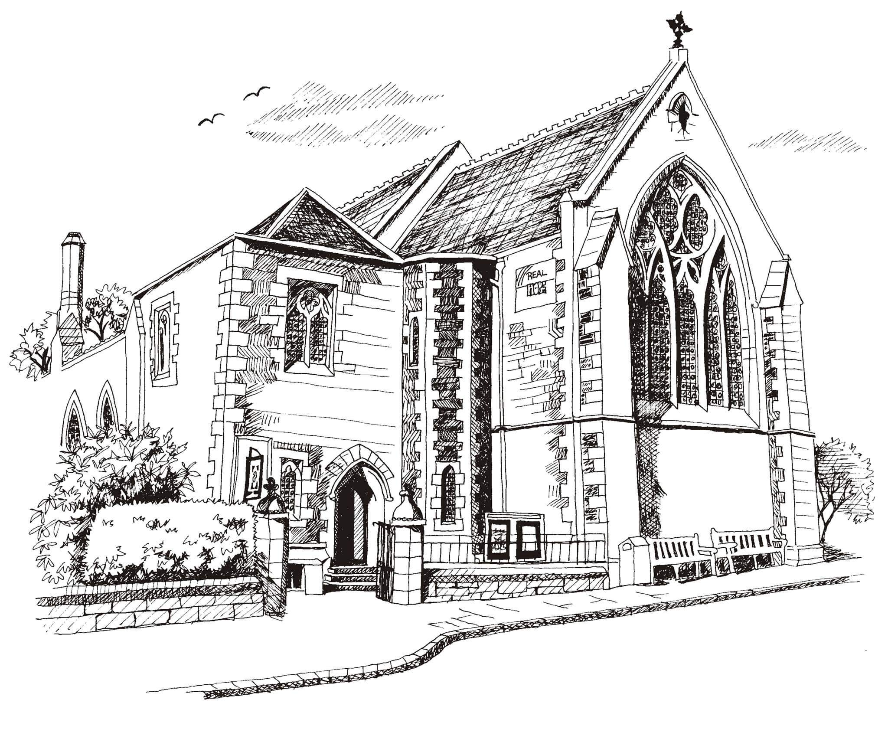**St Philip’s and St James’**

**Church Goldenacre**

**Holy Communion**

**19th March 2023 Lent 4**

|  |  |
| --- | --- |
| Hymn 310 | I heard the voice of Jesus say |
| Liturgy of the Word | Rev Jane Maclaren |
| *Collect for Lent 4*  Almighty God, grant that we, who are weighed down by our sins, may be relieved and encouraged by your grace; through Jesus Christ, our Lord, who lives and reigns with you, in the unity of the Holy Spirit, one God, world without end. | |
| Readings – Norman | 1 Samuel 16.1-13  Ephesians 5.8-14 |
| Gospel – Jane M | John 9.1-41 |
| Reflection | Anne Pankhurst |
| Music for reflection | Will you come and follow me? |
| Intercessions | Una |
| Hymn 150 | Do not be afraid |
| Communion | Rev Jane Maclaren |
| Hymn 364 | Jesus, the name high over all  (Omit v 3 & 5) |

Scottish Liturgy 1982 – Lent St James Goldenacre Reg Charity SC000910

See the website for notice sheets, info and events: <https://www.stpj.org.uk/>