**Notices:** This week David Bunyan will be helping us reflect on ‘The Transfiguration’: the disciples see Jesus alongside Moses and Elijah. They hear God affirming him as God’s own son. The disciples are filled with awe. What do we make of this story ourselves, as we are challenged again to ‘listen to him’?

If you enjoyed last week’ reflection, with the image and Susannah’s music, or if you missed it, see the text and Duncan’s video rendition here [www.stpj.org.uk/blog](http://www.stpj.org.uk/blog/) and click on the ‘Lent begins’ entry.

**Dates for your diary:**

**Communion services every Sunday at 11am** followed by coffee

**Wednesdays 10.30-11.30am – Lent Course and Coffee:** ‘Faith is a verb’ looking at a various verbs that encourage our Christian Life. This week **Weds 8th March** we are thinking about ‘Learning’. In the Church Sitting Room. Come down the north (Ferry Road) side of church to the side door beyond the railings.

**Holy Saturday 8th April** **am** – prayers and church clean-up

**Easter Sunday** **9th April** - Back in church. Jane Green’s last day with us before she retires. Bring and share lunch after the service. More details on Holy Week and Easter coming soon.

**Bishop’s Lent Appeal:** We are supporting St Nicholas Theological seminary in our partner Diocese of Cape Coast, Ghana. They aim to create a water filtration project that will provide clean water for the area as well as funding for their ordinands. This innovative self-help project will secure the next generation of church leaders in Cape Coast: a relationship with the church changes lives in practical as well as spiritual ways. Please donate by cheque or bank transfer to St Philips and St James Church, marked ‘Lent Appeal’. More info here: [www.edinburgh.anglican.org/bishops-lent-appeal-2023/](http://www.edinburgh.anglican.org/bishops-lent-appeal-2023/)

**Contact Details**: Revd Jane Green 07914856606 associate@stpj.org.uk

Revd Jane Maclaren is away this week. Back on Friday 10th March.

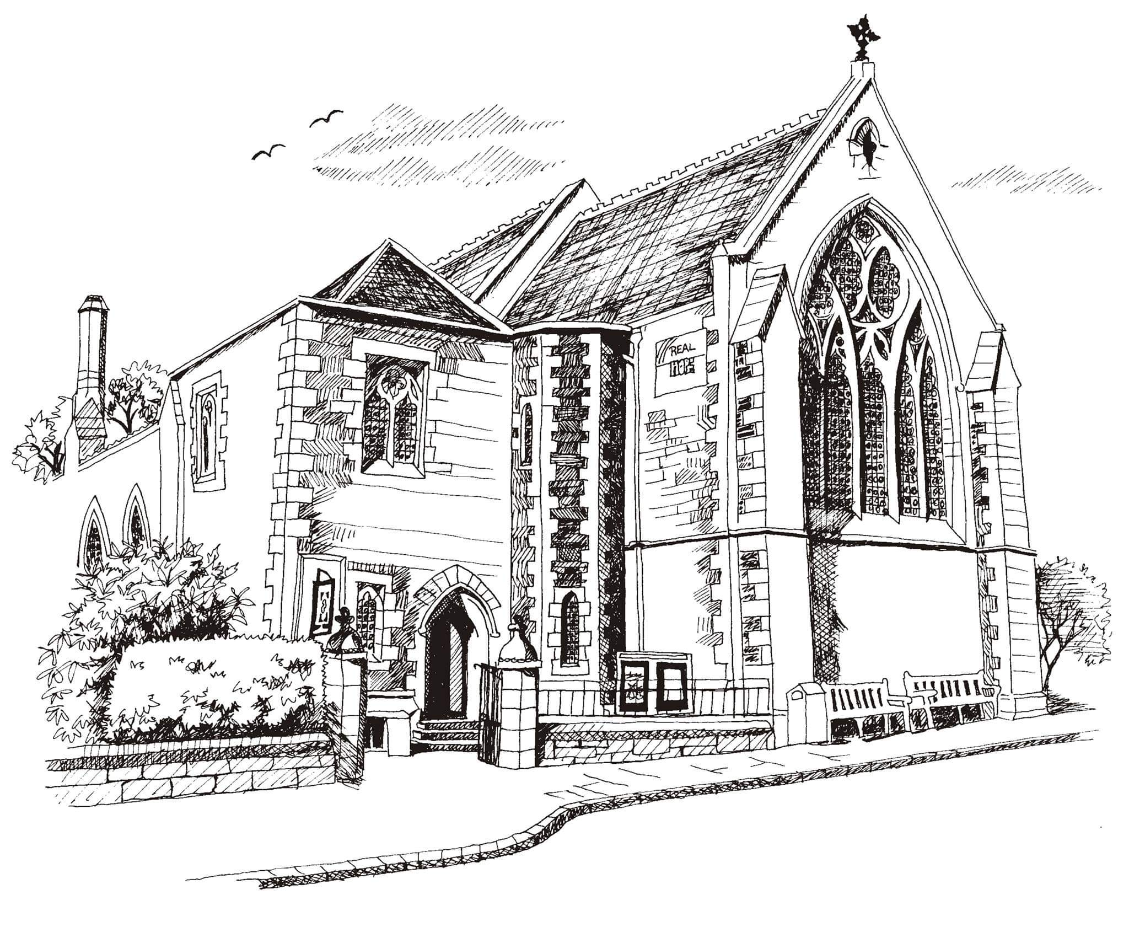**St Philip’s and St James’**

**Church Goldenacre**

**Holy Communion**

**5th March 2023**

**Lent 2**

|  |  |
| --- | --- |
| Hymn 346 | Jesus calls us here to meet him |
| Liturgy of the Word | Rev Jane Green |
| *Collect for Lent 2*  Almighty God, whose Son, Jesus Christ, was wonderfully transfigured before chosen witnesses upon the holy mountain, and spoke of the exodus he would accomplish at Jerusalem: give us strength so to hear his voice and bear our cross, that, in the world to come, we may see him as he is; through the same Jesus Christ, our Lord, who lives and reigns with you, in the unity of the Holy Spirit, one God, world without end. | |
| Readings – Margaret | Genesis 12.1-4a Romans 4.1-5,13-17 |
| Gospel – Jane G | Matthew 17.1-9 |
| Reflection | David Bunyan |
| Intercessions | Rosemary |
| Hymn 625 | Take my life, and let it be |
| Communion | Rev Jane Green |
| Hymn 565 | Praise, my soul, the King of Heaven! |

Scottish Liturgy 1982 – Epiphany St James Goldenacre Reg Charity SC000910

See the website for notice sheets and info: <https://www.stpj.org.uk/>