**Notices:** Today, at the beginning of Lent, we are thinking about ‘Jesus’ temptation in the wilderness’. We will be reflecting on this in a slightly different way from usual using music and image to inspire our thoughts and prayers. What are our ‘wilderness’ areas and how can we stay focussed on God in repentance and self-awareness, knowing that we too are his ‘beloved’?

**Dates for your diary:**

**Communion services every Sunday at 11am** – in the Hall

**Wednesdays 10.30-11.30am – Lent Course and Coffee:** ‘Faith is a verb’ looking at a various verbs that encourage our Christian Life. This week **Weds 1st March** we are thinking about ‘Belonging’. in the Church Sitting Room. Come down the north (Ferry Road) side of church to the side door beyond the railings.

**Holy Saturday 8th April** **am** – prayers and church clean-up

**Easter Sunday** **9th April** - Back in church. Jane Green’s last day with us before she retires. Bring and share lunch after the service. More details on Holy Week and Easter coming soon.

**Friday 3rd March - Book Group** - 2.30pm at Anne Pankhurst's home. Ask Anne or Robert for the address. Discussion on "Munich" by Robert Harris. All are welcome.

**Friday 3rd March – World Day of Prayer** at 2pm Inverleith St. Serf’s Church (enter by Clark Road entrance to Church Centre) Refreshments and chat afterwards

**Contact Details**:

Revd Jane Maclaren 07709905528 rector@stpj.org.uk

Revd Jane Green 07914856606 associate@stpj.org.uk

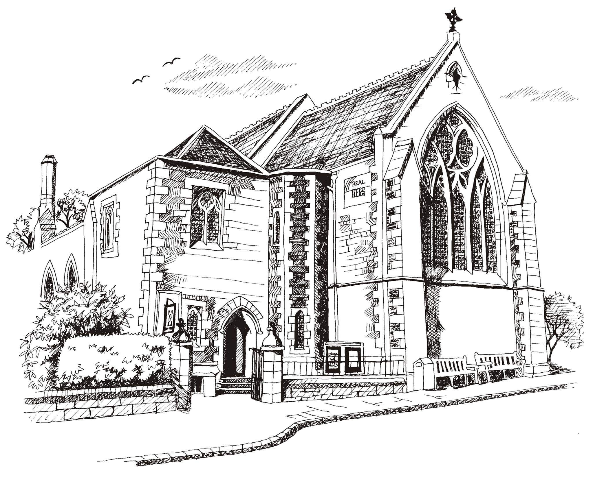**St Philip’s and St James’**

**Church Goldenacre**

**Holy Communion**

**26th February 2023**

**Lent 1**

|  |  |
| --- | --- |
| Hymn 190 | Forty days and forty nights |
| Liturgy of the Word | Rev Jane Maclaren |
| *Collect for Lent 1*  Almighty God, whose Son fasted forty days in the wilderness, and was tempted as we are but did not sin, give us grace to discipline ourselves in submission to your Spirit, that as you know our weakness so we may know your power to save; through Jesus Christ our Lord, who lives and reigns with you and the Holy Spirit, one God, now and for ever | |
| Readings – Jenny | Genesis 2.15-17;3.1-7  Romans 5.12-19 |
| Gospel – Jane G | Matthew 4.1-11 |
| Reflection | Rev Jane Green |
| Intercessions | Robert |
| Hymn 66 | Be still and know that I am God |
| Communion | Rev Jane Maclaren |
| Hymn 299 | I am the bread of life |

Scottish Liturgy 1982 – Epiphany St James Goldenacre Reg Charity SC000910

See the website for notice sheets and info: <https://www.stpj.org.uk/>