**Notices:**

**Today** we celebrate the ‘Epiphany’ of Christ: the ‘showing forth’ of his glory. We remember the wise men coming to pay him homage with those chilling symbols of Gold for kingship, Frankincense for Priesthood, and Myrrh for the anointing of the dead. There is lots of Scripture in today’s service with long, familiar readings from the Old and New Testaments. As you listen, see of there are any words or phrases that jump out at you and savour these in your mind.

We welcome David Bunyan as our preacher today.

**Dates for your diary:**

**Wednesday 11th January 10.30am – Growing with the Gospel resumes this week –** informal prayers and chat about this weeks’ Gospel reading in the Church Sitting Room.Come down the north (Ferry Road) side of church to the porch beyond the railings.

**Sunday 15th January 11am - Holy Communion**

**Saturday 21st January – Burns Supper** – details coming soon. Check the website for updates.

**We wish you a very happy New Year and lots of blessings in 2023!**

**Contact Details** Revd Jane Maclaren 07709905528 rector@stpj.org.uk

Revd Jane Green 07914856606 associate@stpj.org.uk

Jane Green is on holiday this week. If needed, please contact Jane Mac.

Website: <https://www.stpj.org.uk/>

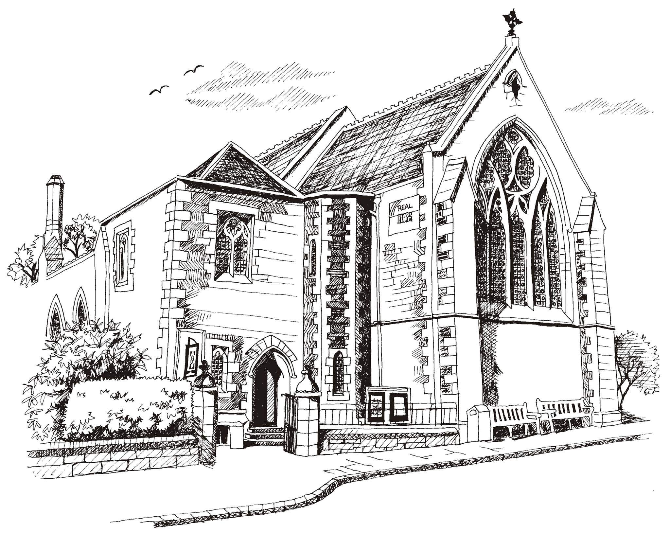**St Philip’s and St James’**

**Church Goldenacre**

**Holy Communion**

**8th January 2023**

**Epiphany**

|  |  |
| --- | --- |
| Hymn 49 | As with gladness - omit v3 |
| Liturgy of the Word | Margaret |
| *Collect for Epiphany*  O God, who, by the guidance of a star, revealed your only-begotten Son to the nations: Grant that we, who know you now by faith, may at the last be led to see your glory face to face; through the same Jesus Christ, our Lord, who lives and reigns with you, in the unity of the Holy Spirit, one God, world without end. Amen. | |
| Readings – Norman | Isaiah 60:1-6; Ephesians 3:1-12 |
| Gospel – Jane M | Matthew 2:1-12 |
| Reflection | Rev David Bunyan |
| Intercessions | Una |
| Hymn 522 | O Worship the Lord |
| Communion | Rev Jane MacLaren |
| Hymn 409 | Lord for the Years |

Scottish Liturgy 1982 – Christmas St James Goldenacre Reg Charity SC000910