**Notices:**

**Today** we are thinking about Christian commitment and what that means. The Gospel tells us about Jesus beginning his ministry in Galilee and calling the first disciples. It contains the wonderful prophecy from Isaiah: ‘The people who walked in darkness have seen a great light’. What does Jesus the ‘Light of the World’ mean for you in your daily life?

**Dates for your diary:**

* **Communion services every Sunday at 11am** – in the Hall
* **Wednesdays at 10.30am – Growing with the Gospel:**

A time of reflection, chat and prayer looking at this weeks’ Gospel reading in the Church Sitting Room. Come down the north (Ferry Road) side of church to the side door beyond the railings.

* **Ash Wednesday 22nd Feb** – more details to come

Please pray for the new Vestry, meeting for the first time 24th Jan

We are currently advertising for a part time church administrator to manage our property and tenants and help with church admin. If you know someone who might be interested, please point them to <https://www.stpj.org.uk/vacancies/>

**Contact Details**:

Revd Jane Maclaren 07709905528 rector@stpj.org.uk

Revd Jane Green 07914856606 associate@stpj.org.uk

For weekly service sheets and other information about life at St James Church, see the website: [www.stpj.org.uk](http://www.stpj.org.uk)

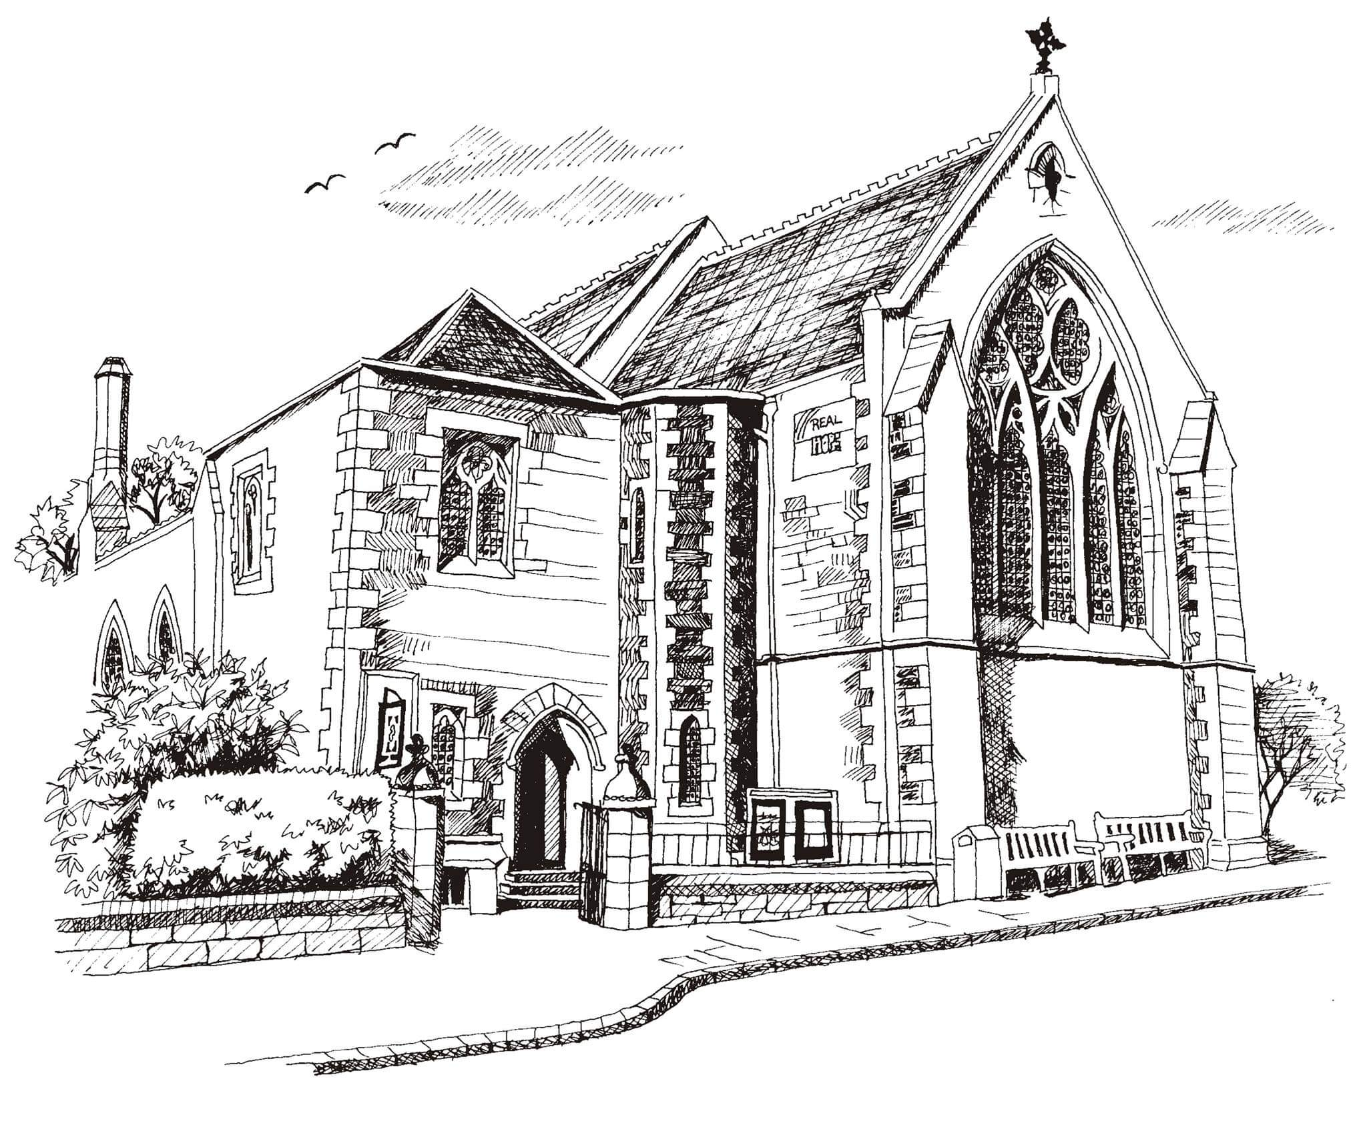**St Philip’s and St James’**

**Church Goldenacre**

**Holy Communion**

**22nd January 2023**

**Epiphany 3**

|  |  |
| --- | --- |
| Hymn 691 | Thy kingdom come, O God |
| Liturgy of the Word | Una |
| *Collect for Epiphany 3*  Almighty God, by grace alone you call us and accept us in your service. Strengthen us by your Spirit, and make us worthy of your call; through Jesus Christ our Lord, who lives and reigns with you and the Holy Spirit, one God, now and for ever. | |
| Readings – Jenny | Isaiah 9.1-4; 1 Corinthians 1.10-18 |
| Gospel – Jane G | Matthew 4.12-23 |
| Reflection | Rev Jane Green |
| Intercessions | Rosemary |
| Hymn 374 | Just as I am |
| Communion | Rev Jane Maclaren |
| Hymn 70 | Be thou my vision |

Scottish Liturgy 1982 – Epiphany St James Goldenacre Reg Charity SC000910

See the website for notice sheets and info: <https://www.stpj.org.uk/>