**Notices:**

**Today** our Gospel reading from John 1 has some powerful images that help us understand more about Jesus: Jesus the Lamb of God, preparing us right at the beginning of the story for his sacrifice to come; the Holy Spirit as a dove, marking Jesus out as ‘The Son of God’; and the anointing of God, marking Jesus out as ‘The Messiah’, the one they have all been waiting for. Then Simon is called ‘Rock’, and although very shaky at times, he remained true to this, becoming a foundation of the Christian Church. Which of these images resonates with you today?

**Dates for your diary:**

* **Communion services every Sunday at 11am** – in the Hall
* **Wednesday 18th January 10.30am – Growing with the Gospel–** informal prayers and chat about this weeks’ Gospel reading in the Church Sitting Room.Come down the north (Ferry Road) side of church to the side door beyond the railings.
* **Saturday 21st January – Burns Night celebration 7.30pm in the hall** – drinks, nibbles, entertainment, dancing. Pick up an invitation for more details. Come and bring friends or family. We have also invited our neighbours at St Davids and St Ninians. Booking is essential.
* **Ash Wednesday 22nd Feb** – more details to come

Please pray for the new Vestry, meeting for the first time 24th January

We are currently advertising for a p/t church administrator. If you know someone who might be interested see <https://www.stpj.org.uk/vacancies/>

**Contact Details** Revd Jane Maclaren 07709905528 rector@stpj.org.uk

Revd Jane Green 07914856606 associate@stpj.org.uk

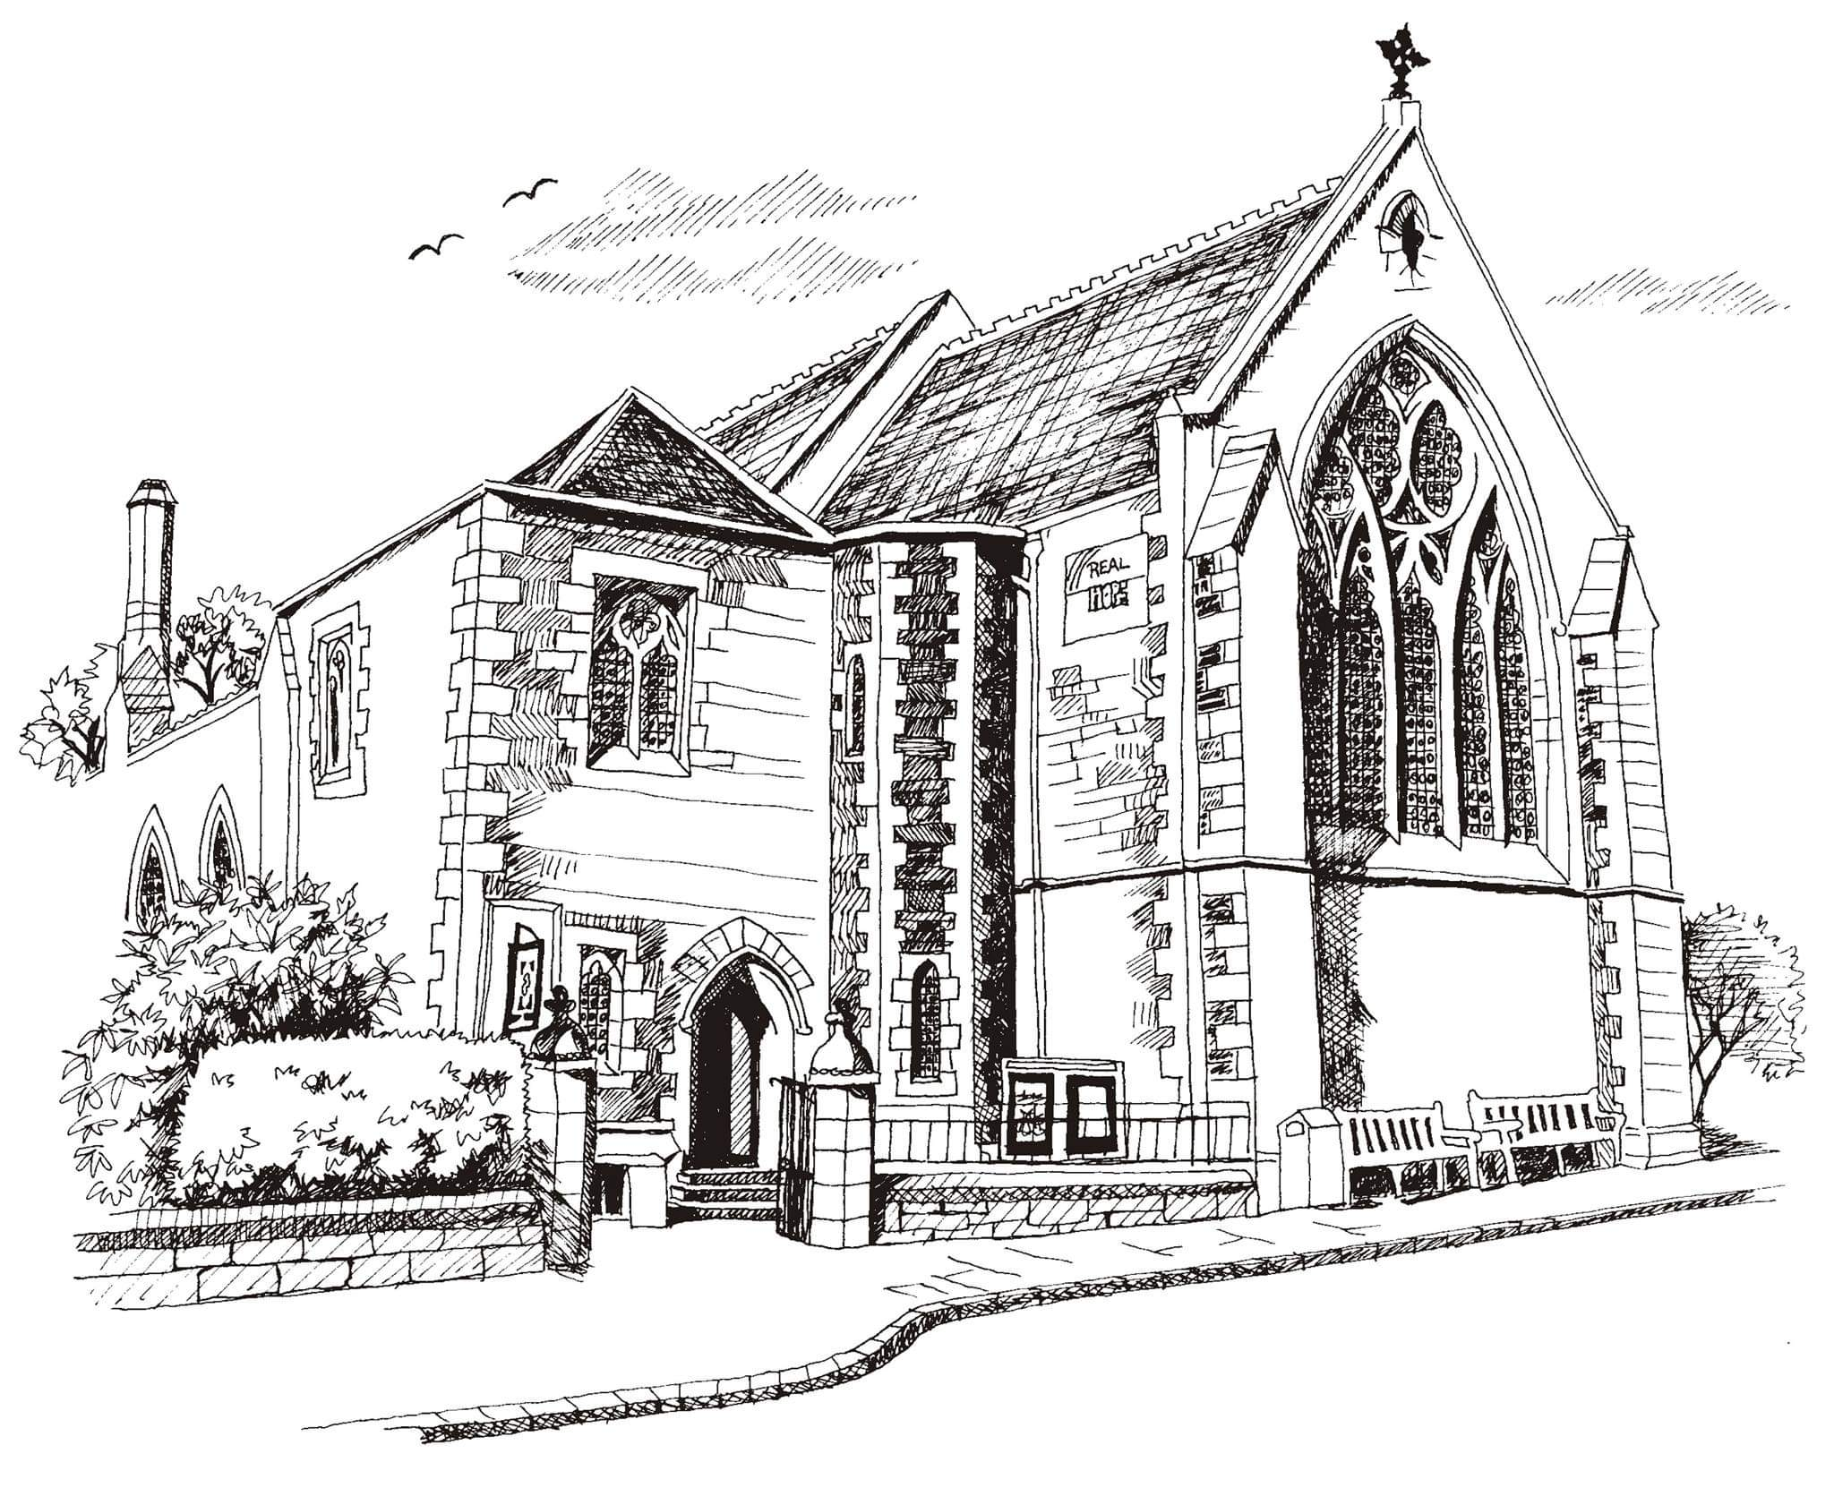**St Philip’s and St James’**

**Church Goldenacre**

**Holy Communion**

**15th January 2023**

**Epiphany 2**

|  |  |
| --- | --- |
| Hymn 249 | Great is thy faithfulness |
| Liturgy of the Word | Rachel |
| *Collect for Epiphany 2*  Almighty and eternal God, ruler of heaven and earth, mercifully hear the prayers of your people, and grant your peace to our times; through Jesus Christ our Lord, who lives and reigns with you in the unity of the Holy Spirit, one God, world without end. Amen. | |
| Readings – Margaret | Isaiah 49.1-7; 1 Corinthians 1.1-9 |
| Gospel – Jane M | John 1.29-42 |
| Reflection | Rev Jane Maclaren |
| Intercessions | Rev Jane Maclaren |
| Hymn 658 | There is a Redeemer |
| Communion | Rev Jane Green |
| Hymn 409 | O for a thousand tongues to sing |

Scottish Liturgy 1982 – Epiphany St James Goldenacre Reg Charity SC000910

See the website for notice sheets and info: <https://www.stpj.org.uk/>