**Notices:**

**Today** we meet John the Baptist: the ‘voice of one calling in the Wilderness’, the signpost to Jesus. How can we be those things today: the voice, the signpost? And what does this mean for our ‘church by the bus stop’?

**Christingles:** Come for tea and chat in the Sitting Room on **Saturday 17th Dec 10.30-12noon** to prepare the Christingles. Please let Jane Mac know if you can help. Our Christingle service is on **Sunday 18th Dec at 11am.**

**Foodbank Donations:** please leave items in the white boxes by 11th Dec for Christmas uplift. Do include Christmas items but no Christmas puddings!

**Wednesdays** 10.30am ‘Growing with the Gospel’ – in the ‘Sitting Room’. Please enter down the north (right hand) side of the church. All welcome. N.B. No meeting on 28th December and 4th January

**Christmas Service flyers:** please take some and invite your friends

**Sunday 11th December:** AGM after the service.

**Saturday 17th December 10.30-12 noon:** preparing Christingles in the hall.

**Sunday 18th December:** Christingle Communion Service

**Christmas Eve:** Carols, Wine and mince pies in the Hall 5pm – 6pm.

**Christmas Day:** 11am Christmas Communion Service

**St Philip’s and St James’ NOTICE of Annual General Meeting**

Sunday 11th December 2022 immediately after the 11am Service.

**Posts currently available for election are:** People’s Warden, Lay Representative and Alternate Lay Representative, and two elected vestry members.If you would like to stand, please see Jane Mac for a list of Vestry responsibilities.

**Nomination forms (to be proposed and seconded) will be available in church from Sunday 27th November 2022.** Signed nomination forms should be returned to Jane Mac or Jane G by noon on Friday 9th December. Any other competent business (questions or issues for comment) must be notified to Jane Mac by Sunday 4th December at the latest.

*For copies of the AGM reports in advance of the meeting email* [rector@stpj.org.uk](mailto:rector@stpj.org.uk)

**Contact Details** Revd Jane Maclaren 07709905528 rector@stpj.org.uk

Revd Jane Green 07914856606 associate@stpj.org.uk

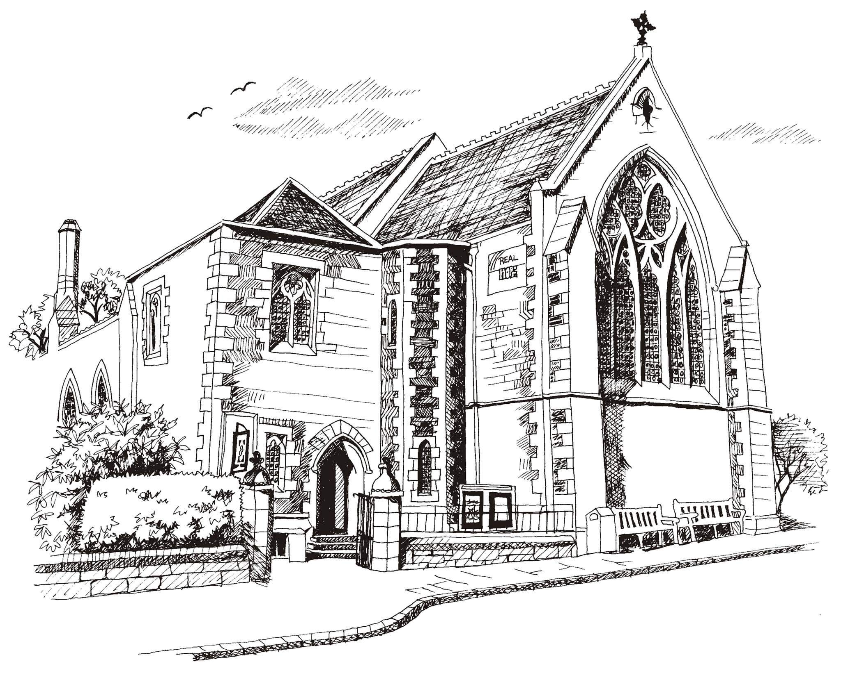**St Philip’s and St James’**

**Church Goldenacre**

**Holy Communion**

**4th December 2022**

**Advent 2**

|  |  |
| --- | --- |
| Hymn 527 | On Jordan’s bank the Baptist’s cry |
| Liturgy of the Word | Rev Jane Maclaren |
| Collect for Advent 2  Almighty God, who sent your servant John the Baptist to prepare your people to welcome the Messiah, inspire us, the ministers and stewards of your truth, to turn our disobedient hearts to you, that when the Christ shall come again to be our judge, we may stand with confidence before his glory; who is alive and reigns with you and the Holy Spirit, one God, now and for ever. | |
| Readings – Toni | Isaiah 11.1-10  Romans 15.4-13 |
| Gospel – Jane G | Matthew 3.1-12 |
| Reflection | Rev Jane Maclaren |
| Choir anthem |  |
| Intercessions | Una |
| Hymn 575 | Put peace into each other’s hands |
| Communion | Rev Jane Green |
| Hymn 221 | God is working his purpose out |

Scottish Liturgy 1982 – Advent St James Goldenacre Registered Charity SC000910