**Notices:**

**Today** the gospel reading tells of John the Baptist, sending a message to Jesus from prison. “What did you go out to see?”, Jesus says. It gets us thinking: what are we looking for in Jesus?

Immediately after the service we will hold a brief AGM. Please stay for this and then coffee.

**Foodbank Donations:** last donations today before Christmas

**Wednesdays** 10.30am ‘Growing with the Gospel’ – in the ‘Sitting Room’. Please enter down the north (right hand) side of the church. All welcome. N.B. No meeting on 28th December and 4th January

**Christmas Service flyers:** please take some and invite your friends

**Saturday 17th December 10.30-12 noon:** preparing Christingles in the hall.

**Sunday 18th December:** Christingle Communion Service

**Christmas Eve:** Carols, Wine and mince pies in the Hall 5pm – 6pm.

**Christmas Day:** 11am Christmas Communion Service

**Contact Details** Revd Jane Maclaren 07709905528 rector@stpj.org.uk

Revd Jane Green 07914856606 associate@stpj.org.uk

Website: <https://www.stpj.org.uk/>

**Agenda for the AGM of St Philips and St James Church Goldenacre, to be held immediately after the morning service**

1. Welcome and opening Prayer
2. Apologies for absence
3. Approval of Minute of last AGM held on 28th Nov 2021
4. Rector’s Report
5. Treasurer’s report and adoption of accounts for y/e 30/9/22
6. Election and appointment of new office bearers
7. Any other competent business
8. Closing prayer and grace

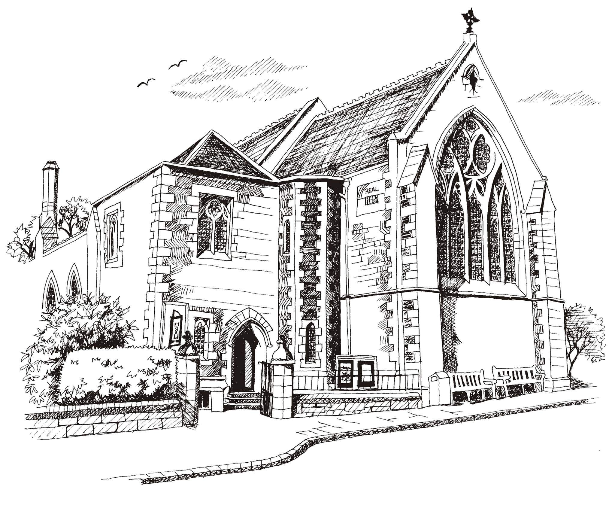**St Philip’s and St James’**

**Church Goldenacre**

**Holy Communion**

**11th December 2022**

**Advent 3**

|  |  |
| --- | --- |
| Hymn 631 | Tell out, my soul, the greatness of the Lord |
| Liturgy of the Word | Margaret |
| Collect for Advent 3  God of power and mercy, you call us once again to celebrate the coming of your Son. Remove those things which hinder love of you, that when he comes he may find us waiting in awe and wonder for him who lives and reigns with you and the Holy Spirit, one God, now and for ever. | |
| Readings – Norman | Isaiah 35.1-10, James 5.7-10 |
| Gospel – Jane G | Matthew 11.2-11 |
| Reflection | Rev Jane Green |
| Choir anthem |  |
| Intercessions | Robert |
| Hymn 634 | The angel Gabriel from heaven came |
| Communion | Rev Jane Maclaren |
| Hymn 137 | Crown him with many crowns |

Scottish Liturgy 1982 – Advent St James Goldenacre Registered Charity SC000910