**Notices:**

**Today** is Advent Sunday, the first day of Advent and of the new church year. We celebrate in various ways: with a new set of liturgy and lectionary, an Advent wreath and candles each week, a change to the colour purple for penitence, and this year, our move to the hall as an act of sacrifice to show our desire to protect God’s beautiful world.

**Christingles:** Come for tea and chat in the Sitting Room on **Saturday 17th Dec 10.30-12noon** to prepare the Christingles. Please let Jane Mac know if you can help. Our Christingle service is on **Sunday 18th Dec at 11am.**

**Foodbank Donations:** please leave items in the white boxes by 11th Dec for Christmas uplift. Do include Christmas items but no Christmas puddings!

**Wednesdays** 10.30am ‘Growing with the Gospel’ – informal Bible reading, chat and prayer in the ‘Sitting Room’. Please enter down the north (right hand) side of the church. All welcome.

**Sunday 11th December:** AGM after the service.

**Saturday 17th December 10.30-12 noon:** preparing Christingles in the hall.

**Sunday 18th December:** Christingle Communion Service

**Christmas Eve:** Carols, Wine and mince pies in the Hall 5pm – 6pm.

**Christmas Day:** 11am Christmas Communion Service

**St Philip’s and St James’ NOTICE of Annual General Meeting**

Sunday 11th December 2022 immediately after the 11am Service.

**Posts currently available for election are:** People’s Warden, Lay Representative and Alternate Lay Representative, and two elected vestry members.If you would like to stand, please see Jane Mac for a list of Vestry responsibilities.

**Nomination forms (to be proposed and seconded) will be available in church from Sunday 27th November 2022.** Signed nomination forms should be returned to Jane Mac or Jane G by noon on Friday 9th December. Any other competent business (questions or issues for discussion) must be notified to Jane Mac by Sunday 4th December at the latest.

**Contact Details**: Revd Jane Maclaren 07709905528 rector@stpj.org.uk

Revd Jane Green 07914856606 associate@stpj.org.uk

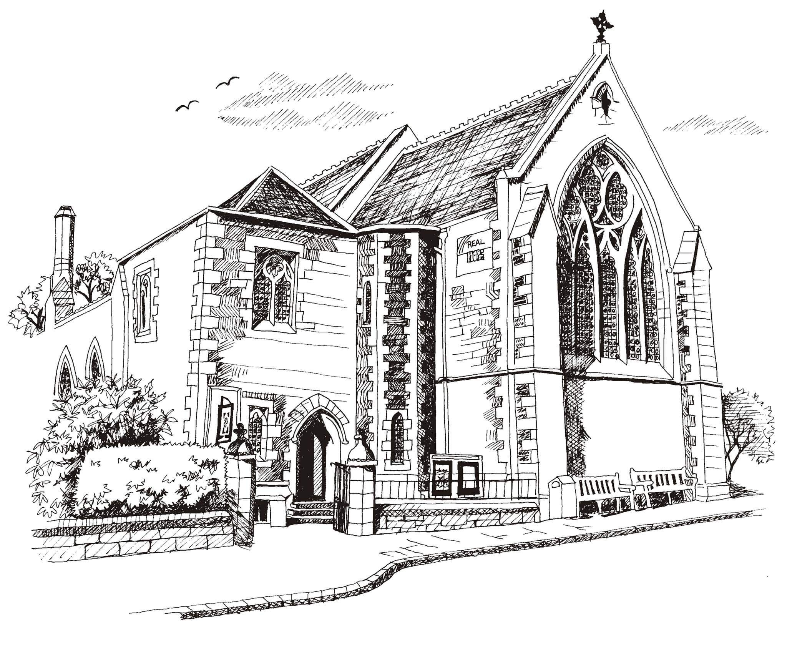**St Philip’s and St James’**

**Church Goldenacre**

**Holy Communion**

**27th November 2022**

**Advent 1**

|  |  |
| --- | --- |
| Hymn 480 | O come, O come, Emmanuel |
| Liturgy of the Word | Margaret |
| Collect for Advent 1  Almighty God, give us grace to cast away the works of darkness and put on the armour of light, now in the time of this mortal life in which your Son Jesus Christ came to us in great humility, that on the last day, when he shall come again in his glorious majesty to judge both the living and the dead, we may rise to the life immortal; through him who lives and reigns with you and the Holy Spirit, one God, now and forever. | |
| Readings – Una | Isaiah 2.1-5  Romans 13.11-14 |
| Gospel – Jane G | Matthew 24.36-44 |
| Reflection | Rev Jane Green |
| Intercessions | Rev Duncan Maclaren |
| Hymn 128 | Come thou long expected Jesus |
| Communion | Rev Jane Maclaren |
| Hymn 282 | Hills of the north, rejoice |

Scottish Liturgy 1982 – Advent.

St James Goldenacre Registered Charity SC000910