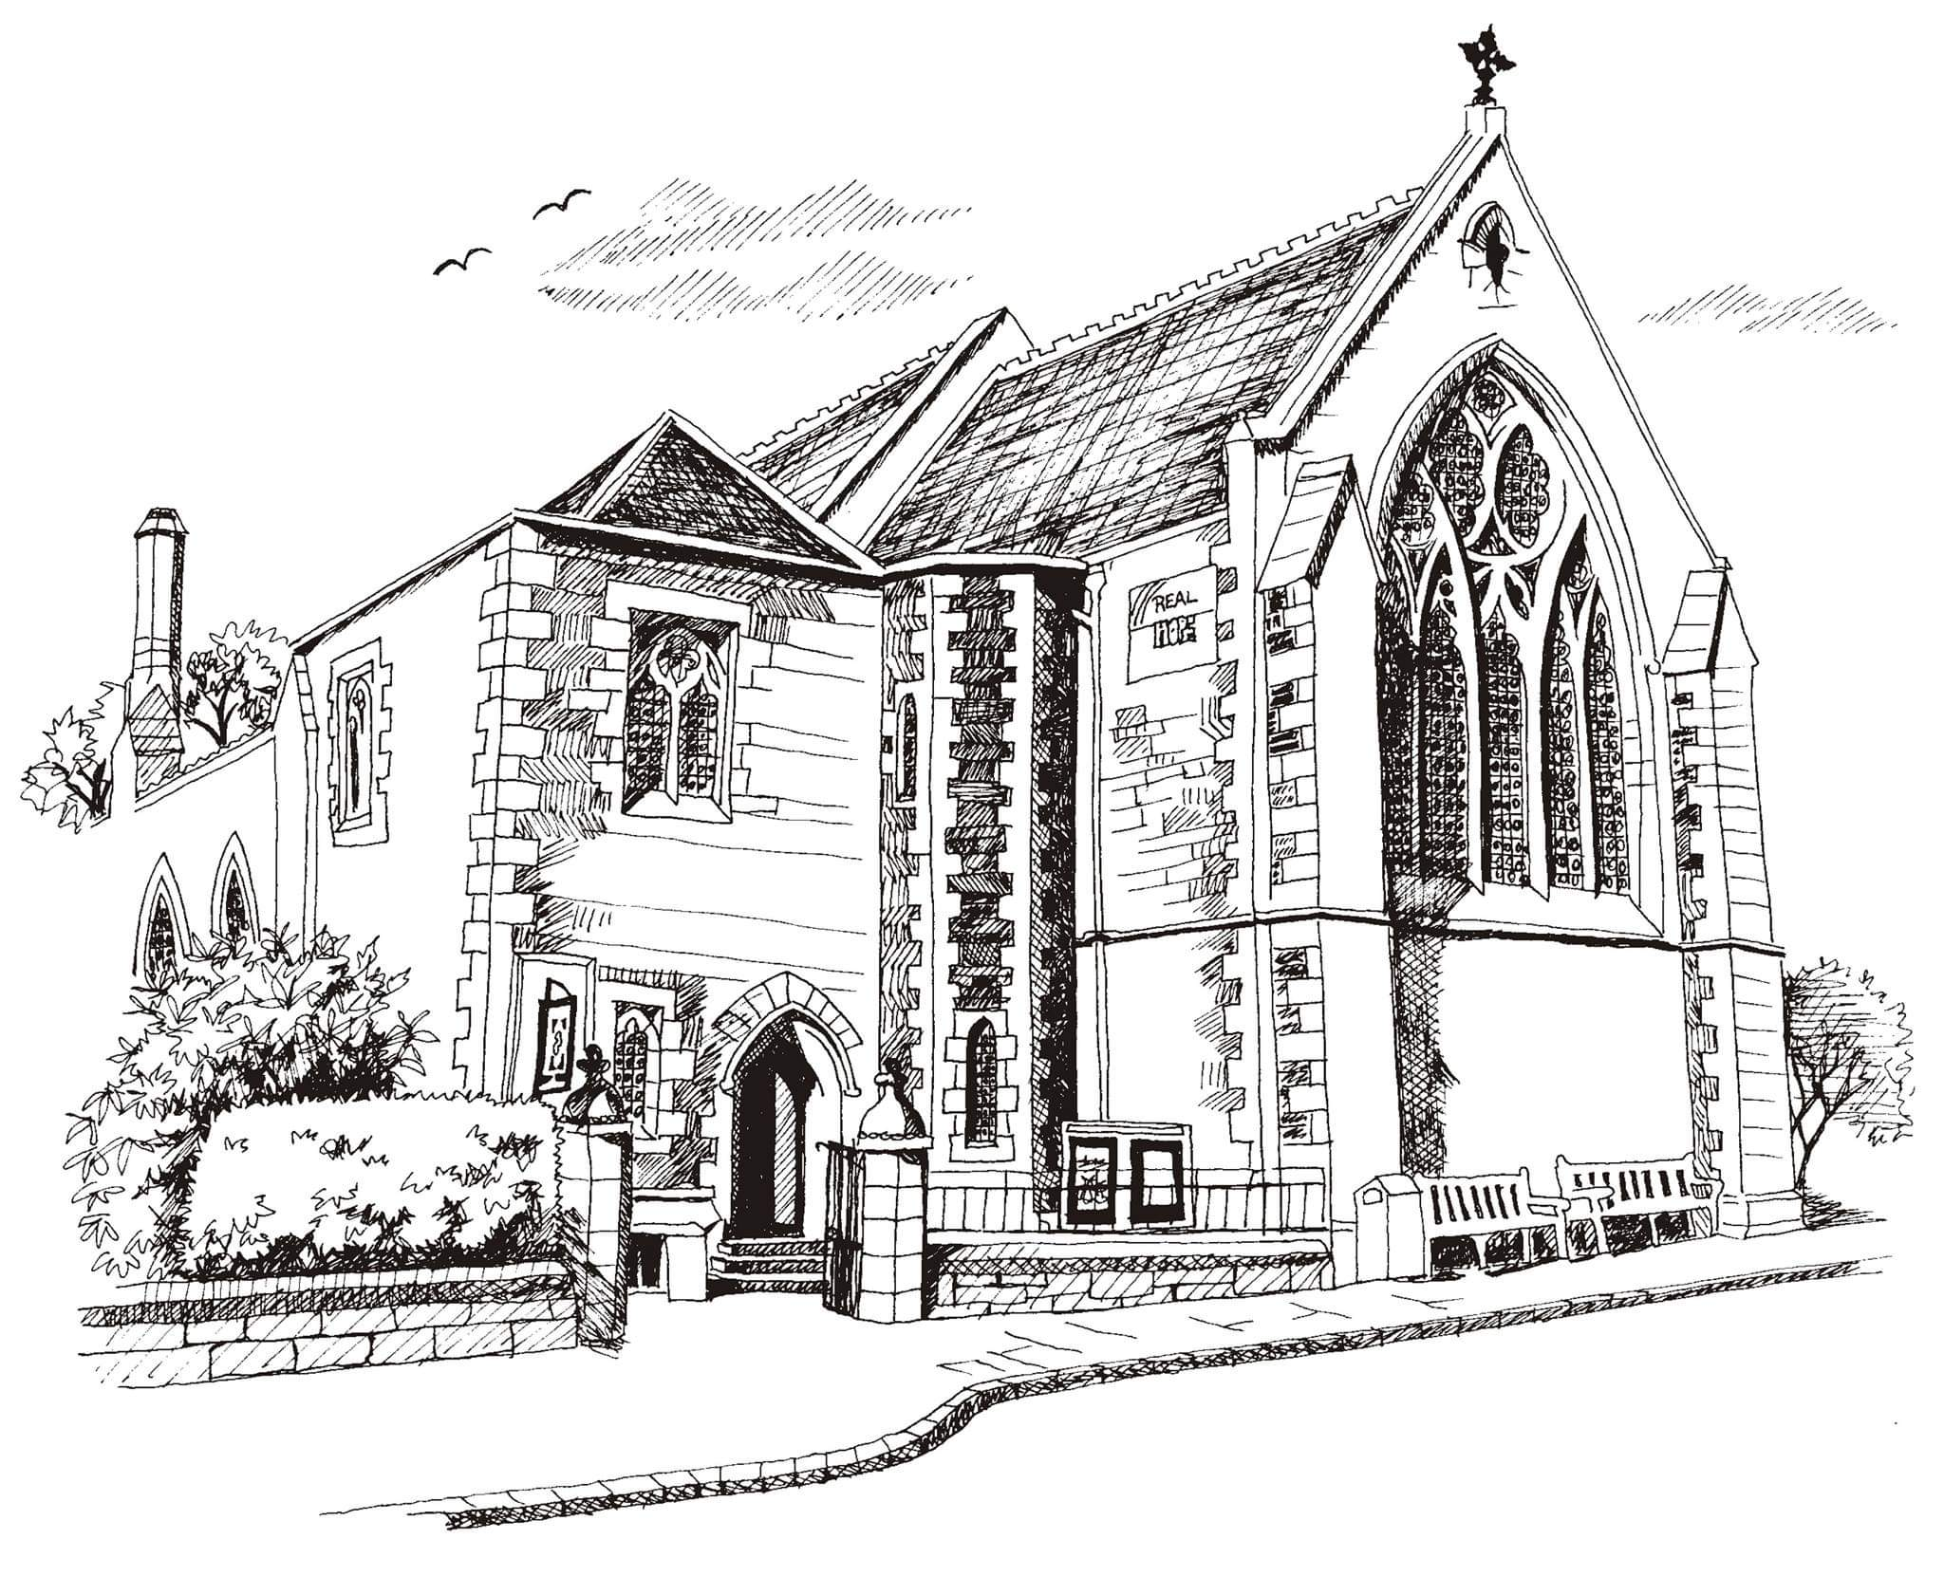**St Philip’s and St James’**

**Church Goldenacre**

**Holy Communion**

**6th November 2022 Pentecost 22**

|  |  |
| --- | --- |
| Hymn 572 | Praise to the Holiest in the height |
| Liturgy of the Word | Rachel |
| Collect for Pentecost 22  Eternal God, who caused all holy scriptures to be written for our learning: grant us so to hear them, read, mark, learn, and inwardly digest them, that we may embrace and ever hold fast the blessed hope of everlasting life, which you have given us in our Saviour Jesus Christ; who lives and reigns with you and the Holy Spirit, one God, for ever and ever. | |
| Readings – Jenny | Job 19.23-27a  2 Thessalonians 2.1-5,13-17 |
| Gospel – Jane M | Luke 20.27-38 |
| Reflection | Rev Jane Maclaren |
| Intercessions | Robert |
| Hymn 437 | Make me a channel of your peace |
| Communion | Rev Jane Green |
| Hymn 534 | O praise ye the Lord! |

Scottish Liturgy 1982 – Ordinary Time

St James Goldenacre Registered Charity SC000910

**Notices:**

**Today** our gospel reading sees Jesus questioned about the resurrection. In this Season of Remembrance, what do we know and understand about life after death? We’ll be thinking about this today. Both Janes are at the clergy conference in Pitlochry this week. Please pray for them and all their clergy colleagues, for refreshment and inspiration as they continue to lead through challenging times.

**Warm Winter Worship in the Hall from Sunday 27th November**

Plans are coming together for our move to the hall. If you have offered to help with the logistics, many thanks and we’ll be in touch.

**Foodbank Donations:** please leave items in the white boxes for monthly uplift. Check the list on the boxes for what to bring.

**New Scots Christmas Appeal (ECM)** Donate to the Christmas hamper appeal by cheque to St. Philip’s & St. James’ Church – mark envelope ‘New Scots Christmas Appeal’ or bank transfer: ‘St Philips and St James Church’ s/c: 80 02 33 acct: 00787069. Description: ‘New Scots’.

**Flower Team Helpers needed:** No experience necessary – just fill a vase! See noticeboard to sign up or speak to Toni or Suzannah.

**Book Club**: Next meeting on 14th November at 2.30pm at Anne Pankhurst's house. We will be discussing ' The Underground Railway' by Colson Whitehead. All are welcome. Come and join us!

**Dates for your diary:**

**Advent Choir:** Weds 9th, 16thand 23rd at 7.30 - 9pm in the hall, for singing in Advent services. Refreshments provided. All welcome.

**Wednesdays** 10.30am ‘Growing with the Gospel’ – informal Bible reading, chat and prayer in church. All welcome.

**Sunday 13th November**: Remembrance Sunday **10.55am** prompt start.

**Sunday 20th November**: Christ the King

**Advent Sunday 27th November**: Worship in the Hall

**Sunday 11th December:** AGM after the service

**Contact Details** Revd Jane Maclaren 07709905528 rector@stpj.org.uk

Revd Jane Green 07914856606 associate@stpj.org.uk

**This week: In case of pastoral emergency please text Jane Mac.**