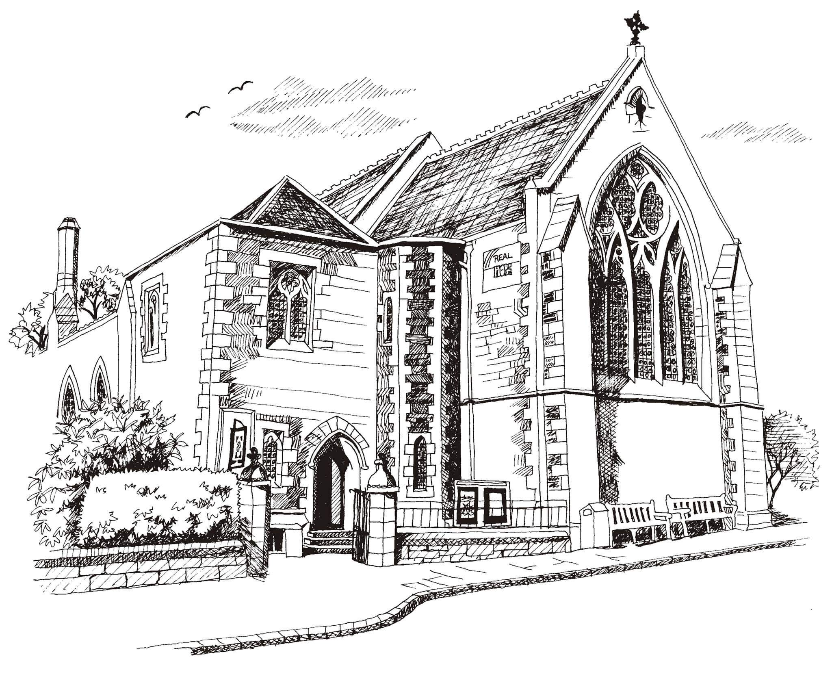**St Philip’s and St James’**

**Church Goldenacre**

**Holy Communion**

**9th October 2022 Pentecost 18**

|  |  |
| --- | --- |
| Hymn NEH 388 | Jesus shall reign |
| Liturgy of the Word | Margaret |
| ***Collect for Pentecost 18***  Almighty God, in our baptism you adopted us for your own. Quicken, we pray, your Spirit within us, that we, being renewed both in body and mind, may worship you in sincerity and truth; through Jesus Christ our Lord, who lives and reigns with you and the Holy Spirit, one God, now and for ever. **Amen**. | |
| Readings - Jenny | 2 Kings 5:1-3, 7-15c; 2 Timothy 2:8-15 |
| Gospel – Jane M | Luke 17:11-19 |
| Reflection | Revd Jane Maclaren |
| Intercessions | Douglas |
| Hymn MP 37 | As the deer pants for the water |
| Communion | Revd Jane Maclaren |
| Hymn NEH 443 | Rejoice the Lord is King |

Scottish Liturgy 1982 – Ordinary Time

St James Goldenacre Registered Charity SC000910

**Notices:**

**This week** we are back in Ordinary time, looking forward to Advent, preparing for the winter, and thinking about how we can implement the messages of Creationtide in our church life. The readings today talk about bringing our whole selves to God, submitting to him, be it for healing, encouragement or correction. What does this mean for us?

**Remembrance for All Saints and All Souls**: you can leave names of loved ones no longer with us, to be read out at our All Saints Day service on 30th October – add to the list on the chairs in the side aisle. Join us for All Souls on Weds 2nd Nov at 10.30am for lighting of candles.

**Admin Support**: We now have Linda Brown working in the office on Wednesdays. Her email is [officestpj22@gmail.com](mailto:officestpj22@gmail.com). Please add this to your address book. If you’re involved in services she may email you!

**Dates for your diary**

**Wednesdays 10.30am ‘**Growing with the Gospel’ – informal Bible reading, chat and prayer in church. All welcome.

**Sunday 16th October 11am:** Guest preacher – the Revd David Coleman, Chaplain, Eco-congregation Scotland

**Sunday 30th October 11am:** All Saints Communion

**Wednesday 2nd November 10.30am:** informal service for All Souls with lighting of candles

**Advent Choir:** rehearsals on Weds 2, 9, 16 &amp; 23 Nov at 7.30-9pm in the hall, for singing in Advent services. Singing is a proven morale booster and good for our mental health in the dark winter days. Come and join us! All welcome.

Contact Details

Revd Jane Green 07914856606 associate@stpj.org.uk

Revd Jane Maclaren 07709905528 rector@stpj.org.uk