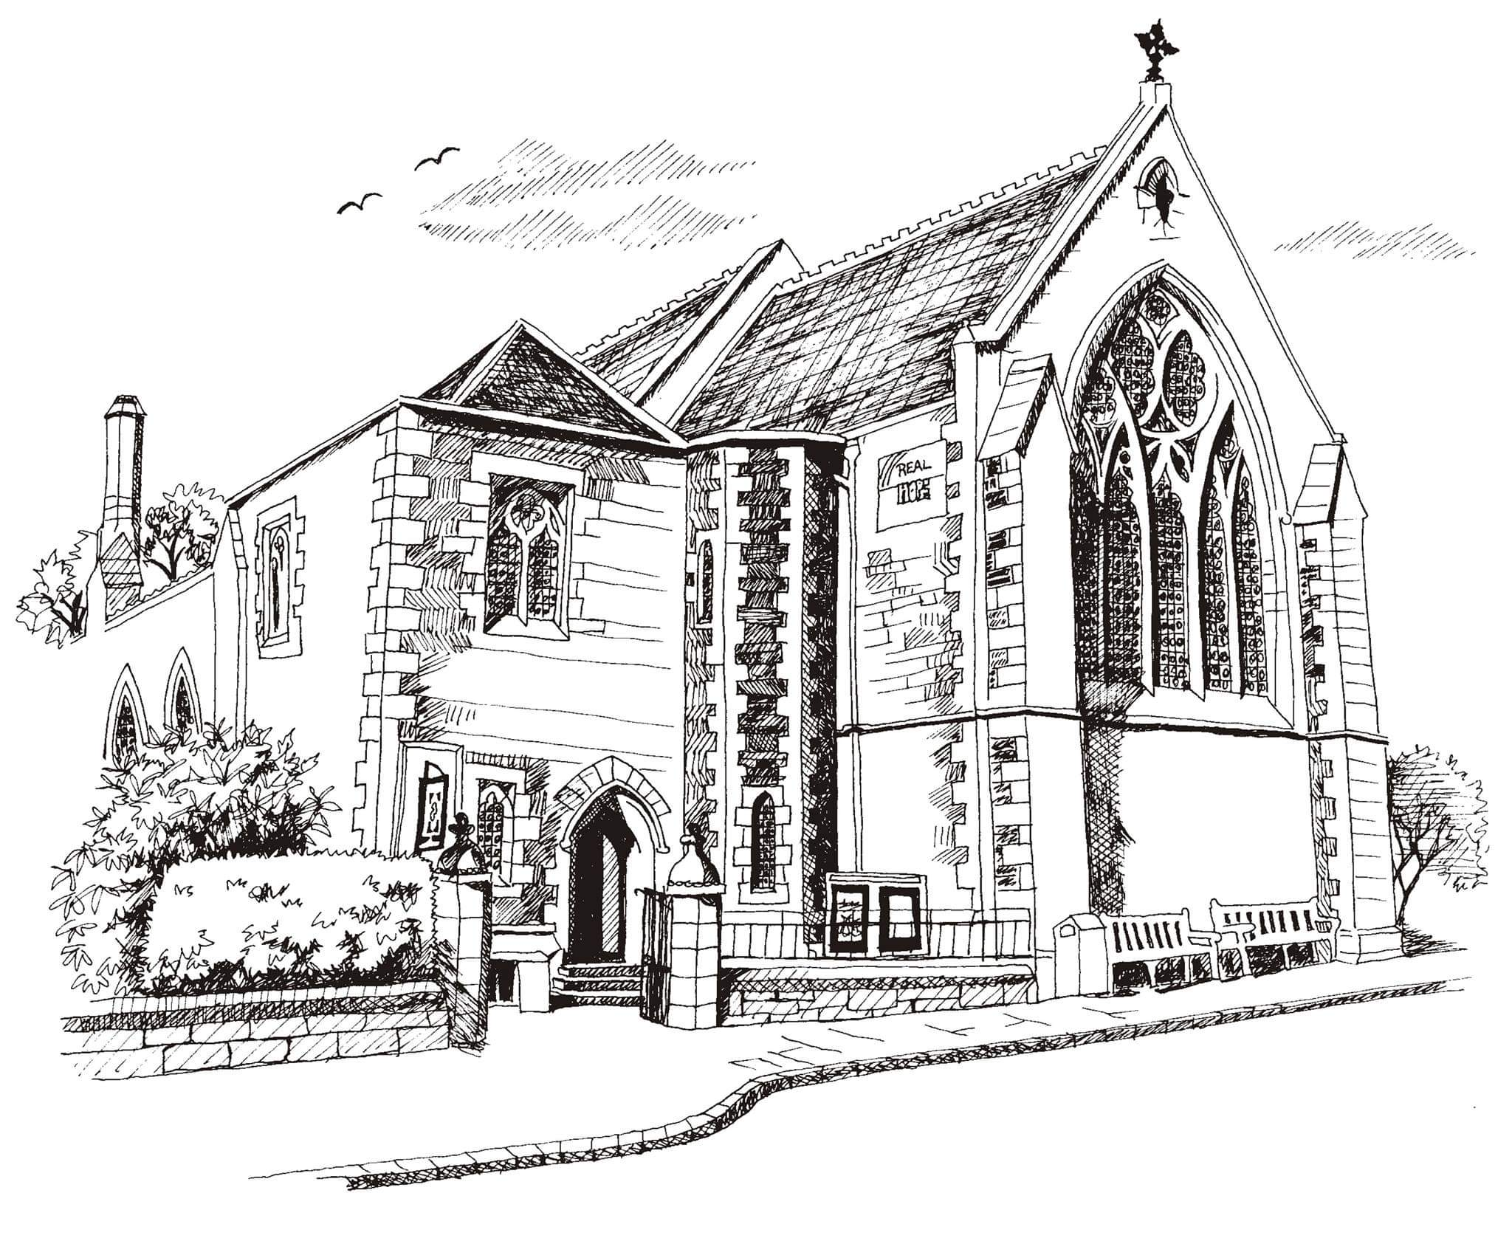**St Philip’s and St James’**

**Church Goldenacre**

**Holy Communion**

**30th October 2022 All Saints**

|  |  |
| --- | --- |
| Hymn NEH 197 | For all the Saints |
| Liturgy of the Word | Rev Jane Maclaren |
| ***Collect for All Saints***  Almighty God, whose people are knit together in one holy Church, the mystical Body of your Son: grant us grace to follow your blessed saints in lives of faith and commitment, and to know the inexpressible joys you have prepared for those who love you; through Jesus Christ our Lord, who lives and reigns with you and the Holy Spirit, one God, now and for ever. | |
| Readings – Margaret | Daniel 7: 1-3, 15-18;  Ephesians 1: 11-23 |
| Gospel – Jane G | Luke 6: 20-31 |
| Reflection | Rev Jane Green |
| ***Prayer for All Saints***  **Lord grant them Eternal rest, and let perpetual light shine upon them. May their souls and the souls of all the faithful departed, through the mercy of God, rest in peace. Amen.** | |
| Intercessions | Duncan |
| Hymn MP 50 | Be still, for the presence of the Lord |
| Communion | Rev Jane Maclaren |
| Hymn NEH 339 | Be thou my vision |

**Notices:**

**Today** we celebrate All Saints and remember those who lived before us, inspired us, and contributed to the life of church and society. Join us for All Souls 10.30am on Weds 2nd Nov with lighting of candles.

**Warm Winter Worship in the Hall from Sunday 27th November:** If you could help in setting up or putting away furniture or have particular suggestions to feed in as we work things out, please email Linda by Tuesday 1st Nov: officestpj22@gmail.com.

**Foodbank Donations:** please leave items in the white boxes for monthly uplift. Check the list on the boxes for what to bring.

**New Scots Christmas Appeal (ECM)** Donate to the Christmas hamper appeal by cheque to St. Philip’s & St. James’ Church – mark envelope ‘New Scots Christmas Appeal’ or bank transfer: ‘St Philips and St James Church’ s/c: 80 02 33 acct: 00787069. Description: ‘New Scots’.

**Flower Team Helpers needed:** No experience necessary – just fill a vase! See noticeboard to sign up or speak to Toni or Suzannah.

**Dates for your diary**

**Advent Choir:** Weds 2nd, 9th, 16th, 23rd and 30th at 7.30 - 9pm in the hall, for singing in Advent services. Please speak to Jane Mac or Douglas if you’re planning to come. All welcome.

**Wednesdays** 10.30am ‘Growing with the Gospel’ – informal Bible reading, chat and prayer in church. All welcome.

**Wednesday 2nd November** at 10.30am: informal service for All Souls

**Sunday 13th November**: Remembrance Sunday 10.55am start.

**Sunday 20th November**: Christ the King

**Advent Sunday 27th November**: Worship in the Hall

Contact Details

Revd Jane Green 07914856606 associate@stpj.org.uk

Revd Jane Maclaren 07709905528 rector@stpj.org.uk

Scottish Liturgy 1982 – Ordinary Time St James Goldenacre Reg SC000910