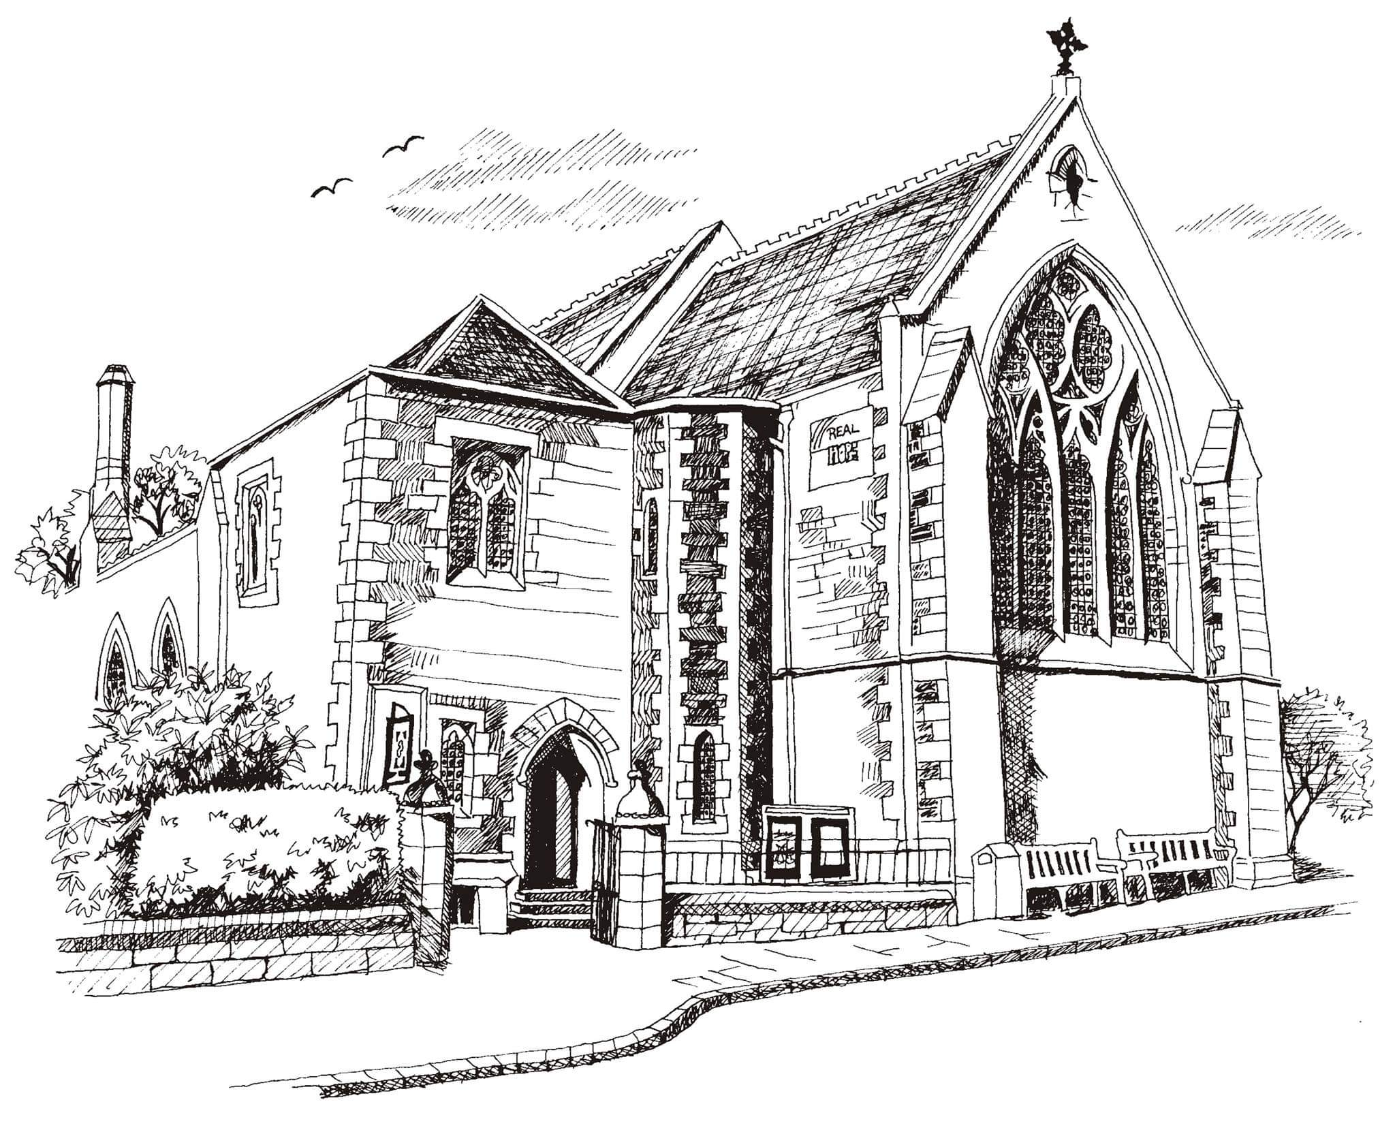**St Philip’s and St James’**

**Church Goldenacre**

**Holy Communion**

**23rd October 2022 Pentecost 20**

|  |  |
| --- | --- |
| Hymn MP 33 | And can it be |
| Liturgy of the Word | Rachel |
| ***Collect for Pentecost 20***  Lord God our redeemer, who heard the cry of your people and sent your servant Moses to lead them out of slavery, free us from the tyranny of sin and death, and by the leading of your Spirit bring us to our promised land; through Jesus Christ our Lord, who lives and reigns with you and the Holy Spirit, one God, now and for ever. | |
| Readings - Robert | Jeremiah 14:7-10, 19-22;  2 Timothy 4: 6-8 |
| Gospel – Jane G | Luke 18:9-24 |
| Reflection | Rev Jane Green |
| Intercessions | Rev Jane Green |
| Hymn MP 67 | Breathe on me breath of God |
| Communion | Rev Jane Green |
| Hymn NEH 372 | He who would valiant be |

Scottish Liturgy 1982 – Ordinary Time

St James Goldenacre Registered Charity SC000910

**Notices:**

We are currently working out all the logistics for Sunday worship in the hall from 27th November to reduce our carbon footprint and stay warm over the winter. If you could help in setting up or putting away furniture or have particular suggestions that you would like to go into the mix as we work things out, please email Linda in the office by Tuesday 1st November at officestpj22@gmail.com.

**All Saints and All Souls**: today is the last chance to leave names of loved ones no longer with us, to be read out on All Saints Day next Sunday 30th October: list on the chairs in the side aisle. Join us for All Souls on Weds 2nd Nov at 10.30am with lighting of candles. Foodbank Donations: please leave items in the white boxes for monthly uplift. Check the list on the boxes for what to bring.

**New Scots Christmas Appeal (ECM)** Donate to the Christmas hamper appeal (£40 per hamper or any amount welcome) by cheque, payable to St. Philip’s & St. James’ Church in an envelope marked ‘New Scots Christmas Appeal’ or by bank transfer: ‘St Philips and St James’ Church’ sort code: 80 02 33, acct: 00787069. Description: ‘New Scots’.

**Dates for your diary**

Advent Choir: rehearsals on Weds 2nd, 9th, 16th, 23rd and 30th at 7.30 - 9pm in the hall, for singing in Advent services. Singing is a proven morale booster and good for our mental health in the dark winter days. Come and join us! All welcome.

**Wednesdays** 10.30am ‘Growing with the Gospel’ – informal Bible reading, chat and prayer in church. All welcome.

**Sunday 30th October** at 11am: All Saints Communion

**Wednesday 2nd November** at 10.30am: informal service for All Souls

**Sunday 13th November**: Remembrance Sunday

**Sunday 20th November**: Christ the King

**Advent Sunday 27th November**: Warm Winter Worship in the Hall

Contact Details

Revd Jane Green 07914856606 associate@stpj.org.uk

Revd Jane Maclaren 07709905528 rector@stpj.org.uk