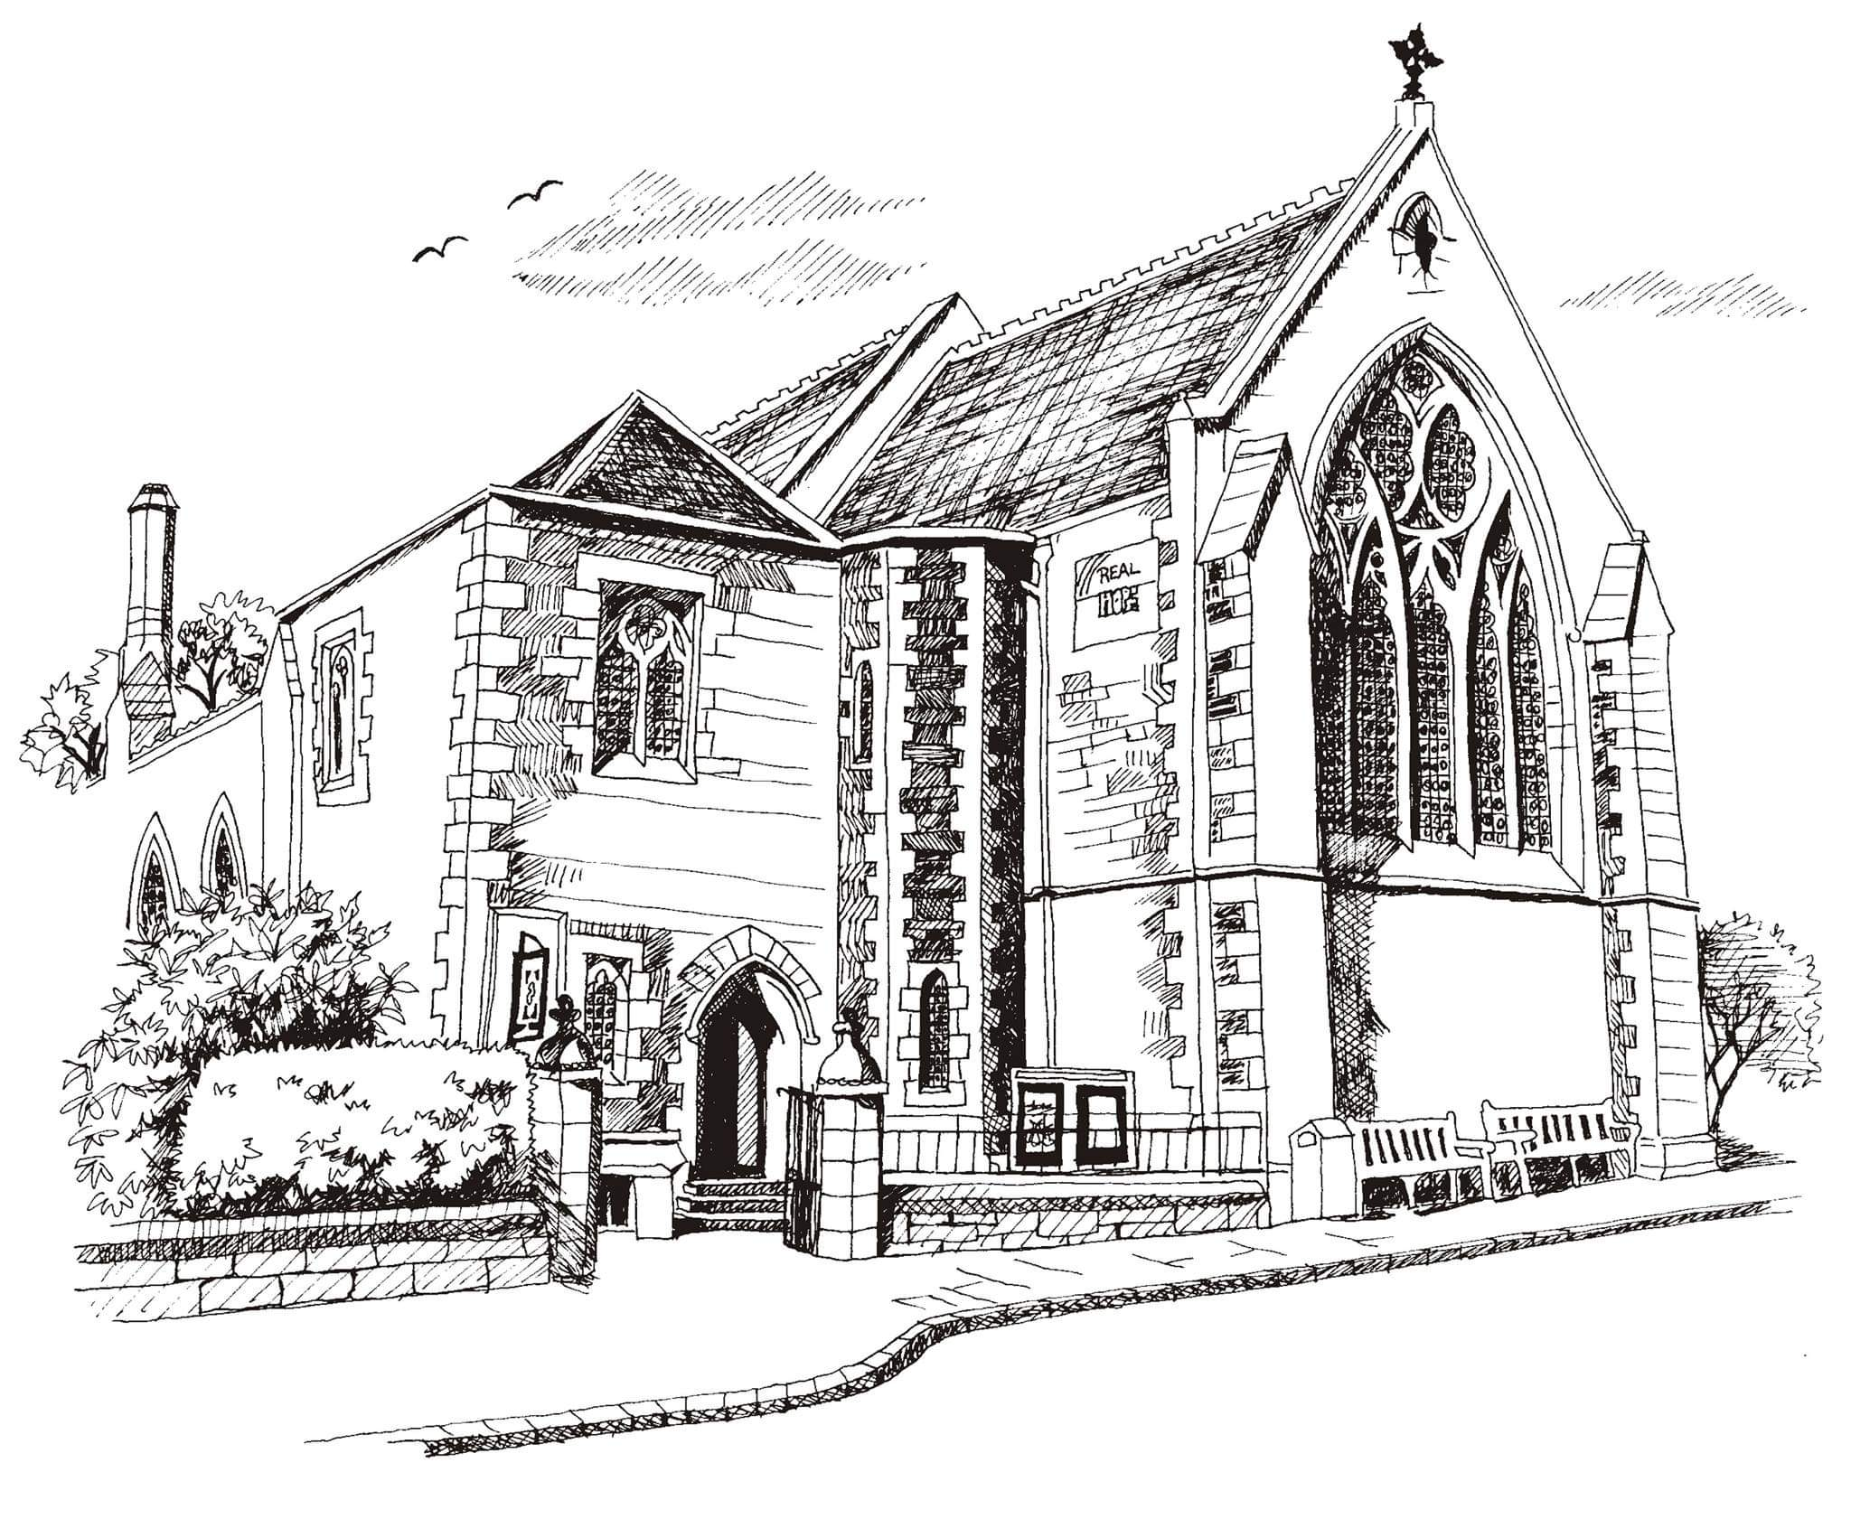**St Philip’s and St James’**

**Church Goldenacre**

**Holy Communion**

**18th September 2022 Creationtide 3**

|  |  |
| --- | --- |
| Hymn MP8 | All earth was dark before you spoke |
| Liturgy of the Word | Rachel |
| ***Collect for Creationtide 3***  God the Creator, in Christ you call all people to the fullness of glory for which you created us in your image: heal our hardened hearts, renew our obedience to your will, and conform our lives to your gracious design, through Jesus Christ our Lord, who lives and reigns with you and the Holy Spirit, one God, now and for ever. **Amen**. | |
| Readings - Jenny | Amos 8:4-7  1 Timothy 2:1-7 |
| Gospel - Imre | Luke 16:1-13 |
| Reflection | Revd Imre Katay-Fodor |
| Intercessions | Margaret |
| Hymn NEH 137 | Come down O love divine |
| Communion | Revd Imre Katay-Fodor |
| Hymn NEH 408 | Love divine |

Scottish Liturgy 1982 – Ordinary Time

St James Goldenacre Registered Charity SC000910

**Notices:**

**Today** we welcome Revd. Imre Katay-Fodor, kindly covering for us while Jane M and Jane G are taking a break. We’re still in the season of Creationtide. Look under ‘Seasons’ on the website [www.stpj.org](http://www.stpj.org).uk to find out more about what this means. You can also download a copy of this service sheet, the ‘Eco tips’, and ‘10 commandments for Eco-friendly living’ from the ‘Latest’ section. We are still in a period of national mourning for the Queen, hence purple again today. In addition to our service of Remembrance last week, you may want to observe the one minute’s silence at 8pm today.

**Dates for your diary**

**Wednesdays at 10.30 ‘**Growing with the Gospel’ – informal Bible reading, chat and prayer in church. All welcome.

**Friday 23rd September Book Group** 2.30pm in the small hall. All welcome. For more information see Robert Greenshields.

**Sunday 25th October:** Talk from Water Aid, one of our mission partners, at coffee time after the service.

**Sunday 2nd October: Harvest Festival.**

**Harvest Choir:** We will be singing “For the beauty of the earth” by John Rutter. Copies available from Jen beforehand for practice. Rehearsals: Saturday 1st October 10am -11.30am and 10am on Sunday 2nd before the service.

**Advent Choir:** rehearsals on Weds evenings in November. More info to follow. Speak to Douglas if you’re interested.

Contact Details:

Revd Jane Green 07914856606 [associate@stpj.org.uk](mailto:associate@stpj.org.uk)

(Revd Jane Maclaren is away this week)