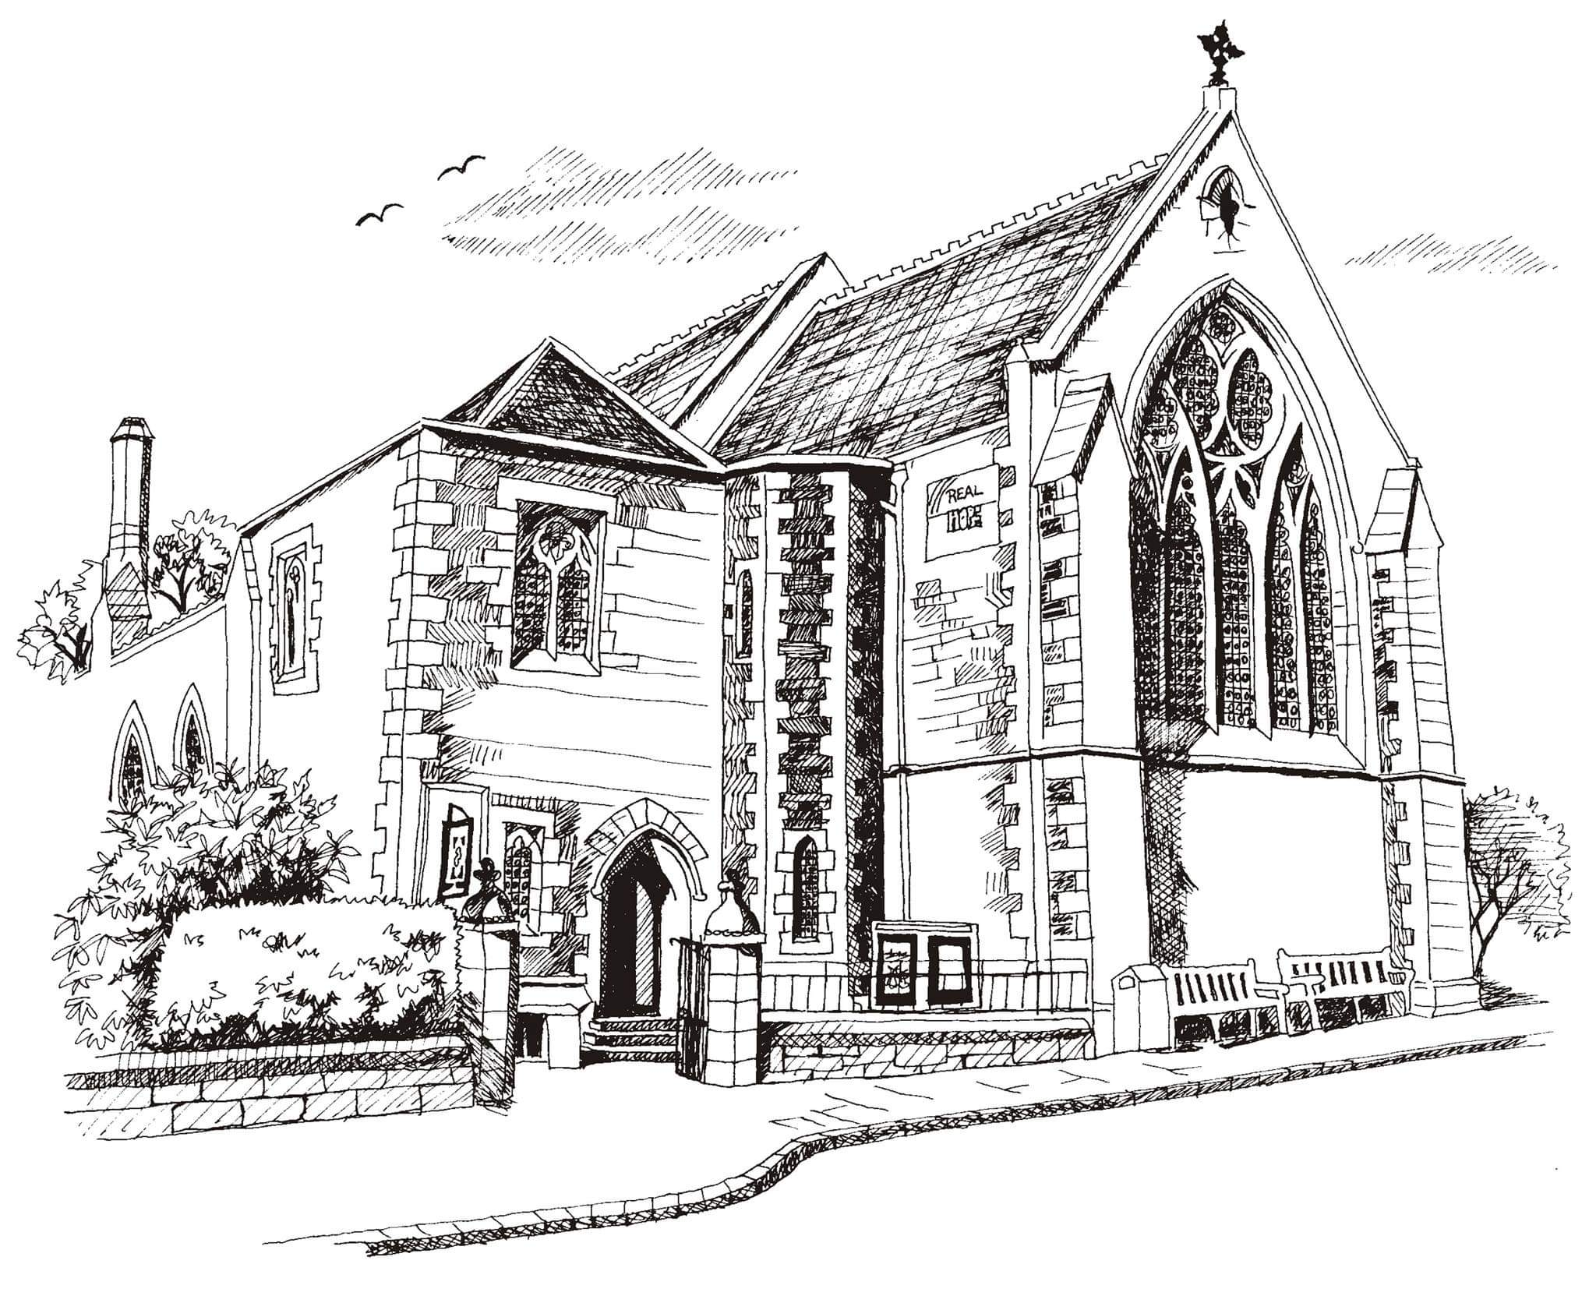**St Philip’s and St James’**

**Church Goldenacre**

**Holy Communion**

**2nd October 2022 Harvest Festival**

|  |  |
| --- | --- |
| Hymn NEH 259 | Come, ye thankful people come |
| Liturgy of the Word | Revd Jane MacLaren |
| ***Collect for Harvest Festival***  God, in whom all things are possible, you crown the year with your goodness and give us the fruits of the earth in their season: grant that we may use them to your glory, so that none may hunger, none may thirst, and all may cherish the gifts of your creation, through Jesus Christ our Lord, who lives and reigns with you and the Holy Spirit, one God, now and for ever. **Amen**. | |
| Readings - Una | Hab 1:1-4; 2:1-4; 2Timothy 1:1-14 |
| Gospel – Jane M | Luke 17:5-10 |
| Reflection | Douglas Kerr |
| Anthem | For the beauty - John Rutter |
| Intercessions | Robert |
| Hymn MP 624 | Take my life |
| Communion | Revd Jane Green |
| Hymn MP 501 | O Jesus I have promised |

Scottish Liturgy 1982 – Ordinary Time

St James Goldenacre Registered Charity SC000910

**Notices:**

**Today** we celebrate Harvest Festival. We are often far removed from food production when we live in a city. Today reminds us to give thanks to God for the miracle of all the growing things that nourish us and sustain life, and to pray for a more equitable spread of resources in the world.

This is the last Sunday of Creationtide. To find out more, look under ‘Seasons’ on the website www.stpj.org.uk. You can also download a copy of this service sheet, the ‘Eco tips’, and ‘10 commandments for Eco-friendly living’ from the ‘Latest’ section on the website.

All food brought today will be donated to the Basics Bank. Thanks to all involved in decorating the church and singing in the Harvest choir.

**Dates for your diary**

**Wednesdays 10.30am ‘**Growing with the Gospel’ – informal Bible reading, chat and prayer in church. All welcome.

**Sunday 16th October 11am:** Guest preacher – the Revd David Coleman, Chaplain, Eco-congregation Scotland

**Sunday 30th October 11am:** All Saints Communion

**Wednesday 2nd November 10.30am:** informal service for All Souls with lighting of candles

**Advent Choir:** rehearsals on Weds evenings in November. More info to follow. Speak to Douglas if you’re interested.

Contact Details

Revd Jane Green 07914856606 associate@stpj.org.uk

Revd Jane Maclaren 07709905528 rector@stpj.org.uk