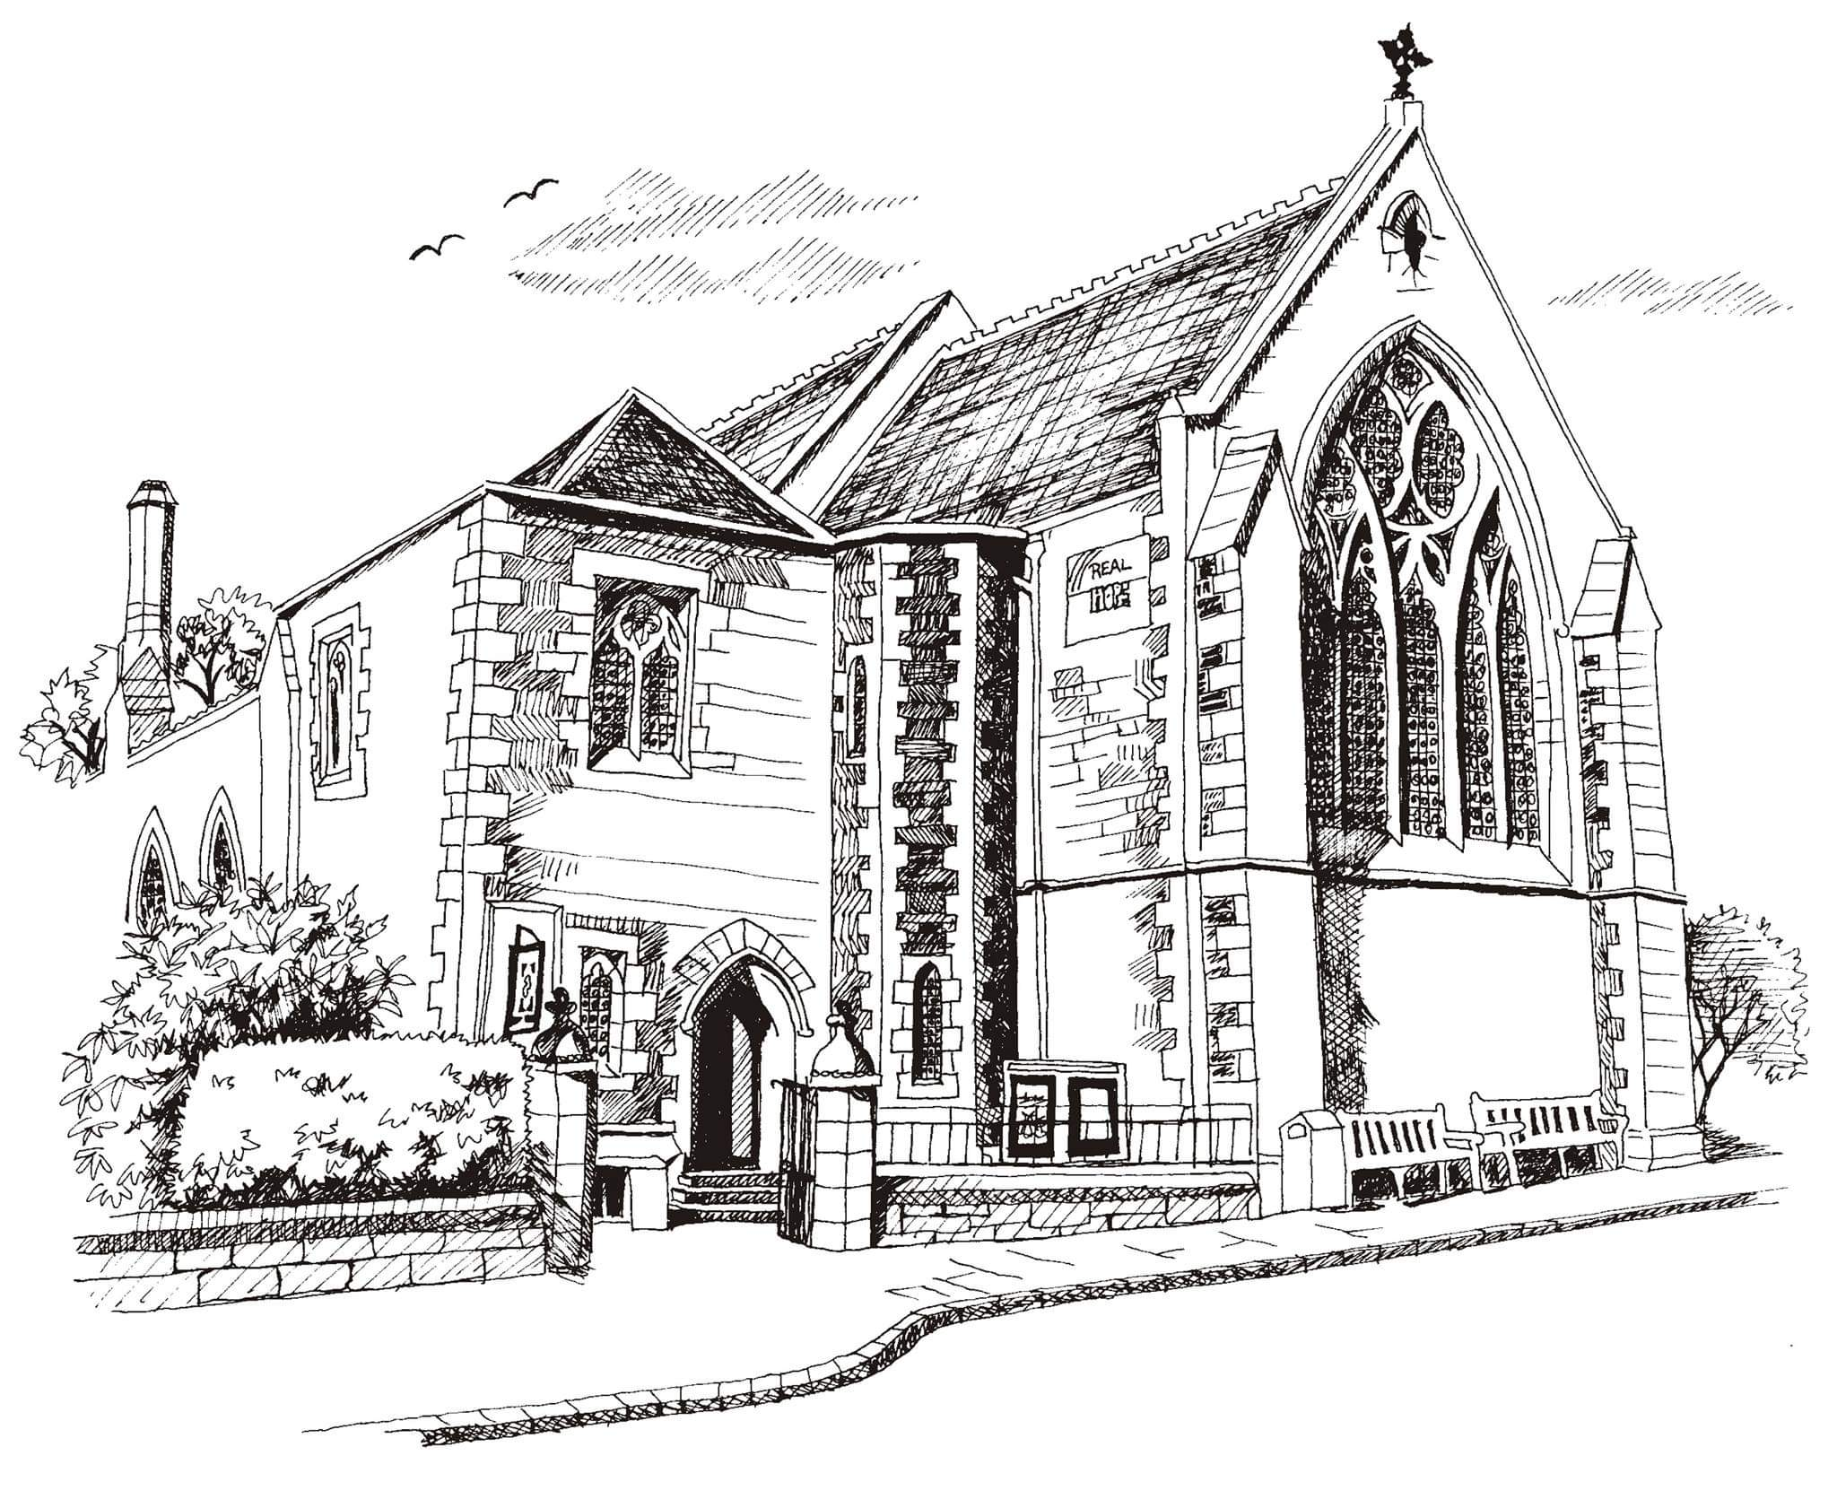**St Philip’s and St James’**

**Church Goldenacre**

**Holy Communion**

**25th September 2022 Creationtide 4**

|  |  |
| --- | --- |
| Hymn NEH 377 | Immortal invisible |
| Liturgy of the Word | Jenny |
| ***Collect for Creationtide 4***  O God, in whose wisdom all things have been established in order: enlighten the people you have saved, that they may consider the greater wonder of your new creation, brought forth in the fullness of time, through the death and resurrection of Jesus Christ, our Lord, through Jesus Christ our Lord, who lives and reigns with you and the Holy Spirit, one God, now and for ever. **Amen**. | |
| Readings - Bill | Amos 6:1a, 4-7; 1 Timothy 6:6-19 |
| Gospel - David | Luke 16:19-31 |
| Reflection | Anne Pankhurst |
| Intercessions | Una |
| Hymn MP 467 | Morning has broken |
| Communion | Revd David Todd |
| Hymn MP 200 | Great is thy faithfulness |

Scottish Liturgy 1982 – Ordinary Time

St James Goldenacre Registered Charity SC000910

**Notices:**

**Today** we welcome Revd. David Todd who will be presiding at Communion. Anne Pankhurst, member of our Eco group, will be giving our reflection. We also welcome Water Aid who will be speaking to us about their work at coffee time today. They are one of the charities we support as a church. We’re still in the season of Creationtide. Look under ‘Seasons’ on the website www.stpj.org.uk to find out more about what this means and why it’s an important part of our church calendar. You can also download a copy of this service sheet, the ‘Eco tips’, and ‘10 commandments for Eco-friendly living’ from the ‘Latest’ section on the website.

**Dates for your diary**

**Wednesdays at 10.30 ‘**Growing with the Gospel’ – informal Bible reading, chat and prayer in church. All welcome.

**Sunday 2nd October: Harvest Festival.**

**Harvest Choir:** We will be singing “For the beauty of the earth” by John Rutter. Copies available from Jen beforehand for practice. Rehearsals: Saturday 1st October 10am -11.30am and 10am on Sunday 2nd before the service.

**Harvest Flowers:** Members of the congregation are invited to help decorate the church ready for Harvest Festival next week. Please speak to Toni today – or email or phone her. Meet in church (or stay on) after the choir rehearsal from 11.30 to 1pm latest.

**Advent Choir:** rehearsals on Weds evenings in November. More info to follow. Speak to Douglas if you’re interested.

Contact Details – (both Janes are back from Monday)

Revd Jane Green 07914856606 associate@stpj.org.uk

Revd Jane Maclaren 07709905528 rector@stpj.org.uk